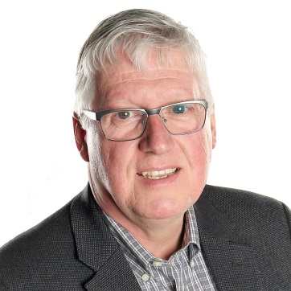

Klaas Rodenburg, MA, C.Tech, LEED AP, ENV SP

Klaas is a Director and Communications Chair for the Fusion Energy Council of Canada (FECC) a volunteer organization focused on advocating for nuclear fusion to harness the power of the stars to provide endless clean energy on Earth. He is a co-author of the “Status of Fusion Energy” report commissioned by the Government of Alberta in 2014 to assess the various approaches to realizing the promise fusion energy and associated commercial opportunities. This presentation is an update of that report.

Klaas has a Bachelor of Arts degree with a major in Industrial Design (1984) and a Master of Arts in Communications and Technology (MACT) (2009) both at the University of Alberta. He was the Sustainable Design Coordinator at Stantec before moving to Mammoet in 2014 as a Quality Advisor where he served as a leader of the Sustainovation Steering Committee, a Global initiative responsible for identifying and implementing innovative solutions to sustainability challenges faced by Mammoet and its sister companies. He served as the volunteer President of the Alberta Council of Technologies (ABCtech) and is a current member of the City of Edmonton’s Energy Climate Resilience Committee, he has taught sustainability courses at NAIT, Lakeland College and U of A and has presented at a variety of sustainability focused events.

