Fusion Energy Reaches Prime Time
Over the last three years, electricity generation from fusion has moved from the realm of science fiction to the brink of serious development. A lot has happened, but challenges remain before fusion arrives on the grid.
For close to a century, electricity generation from fusion remained the stuff of science fiction, little more than a plot point that served to separate the present from the future. All that came to a dramatic end over the past three years, as a cascading series of scientific, technical, business, and political developments yanked fusion out of the labs and onto the front pages.
Fusion scientists have been quietly working toward practical electricity generation since the 1950s (see “Fusion Energy Is Coming, and Maybe Sooner than You Think” in the June 2020 issue of POWER). These incremental advances reached a critical mass in 2021 as the financial and political establishments finally began seeing fusion energy as a worthy investment—not for the distant future but as something that could be achieved within the next decade.
This article is intended as an update to the 2020 piece and will review the key events since its publication. No single development is responsible for the dramatic shift in attention toward fusion, and the organization below should not be taken as indication of relative importance, as all of them have contributed.

Scientific Breakthroughs
While there has been continued progress in fusion science over the past several years, three events stand out because of their significance in reaching practical generation.
The first, in May 2021, took place at the Experimental Advanced Superconducting Tokamak (EAST) in Hefei, China. Researchers at EAST maintained a steady-state fusion reaction for a remarkable 1,056 seconds—almost 20 minutes. This achievement, in a device using a design and technologies similar to those likely to be employed by future power plants, clearly indicates that long-term operation is possible.
The next event took place only months later. The Joint European Torus (JET), at the UK Atomic Energy Authority’s (UKAEA’s) Culham Laboratory in Oxfordshire, is the largest fusion tokamak in the world (Figure 1) and has held the record for fusion power since 1997. That record—21.7 megajoules (MJ)—was smashed in late 2021 with a fusion pulse that achieved 59 MJ. The significance of this experiment was not just in the increased power but also because JET has been reconfigured in recent years to help prepare for operations on the ITER experiment under construction in France.
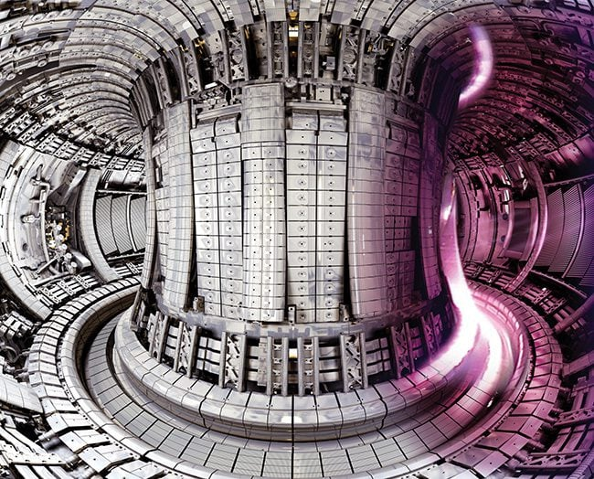
1. The Joint European Torus (JET) at the Culham Centre for Fusion Energy in the UK is the central research facility of the European Fusion Programme, and the largest tokamak in the world. Courtesy: UK Atomic Energy Authority

The pulse was part of a dedicated experimental campaign designed by EUROfusion, the scientific organization that operates JET, to apply advances from the past several decades to ITER-relevant conditions. Though the pulse lasted only five seconds, the results bode well for scaling up the approach at ITER.
“This achievement is the result of years-long preparation by the EUROfusion team of researchers across Europe,” EUROfusion Programme Manager Tony Donné said at the time. “The record, and more importantly the things we’ve learned about fusion under these conditions and how it fully confirms our predictions, show that we are on the right path to a future world of fusion energy. If we can maintain fusion for five seconds, we can do it for five minutes and then five hours as we scale up our operations in future machines.”
Put another way, the results on JET strongly suggest that the magnetic fusion technology being used for ITER can produce the net energy that it is designed to. JET is not large or powerful enough to reach that milestone on its own, but the much larger ITER machine will be, once it begins operations in the 2030s.
As impressive as the JET achievement was, an even more dramatic event occurred the following year. In December 2022, researchers at the National Ignition Facility (NIF) at Lawrence Livermore National Laboratory in California achieved something that had never been managed before: net energy from a fusion reaction (Figure 2).
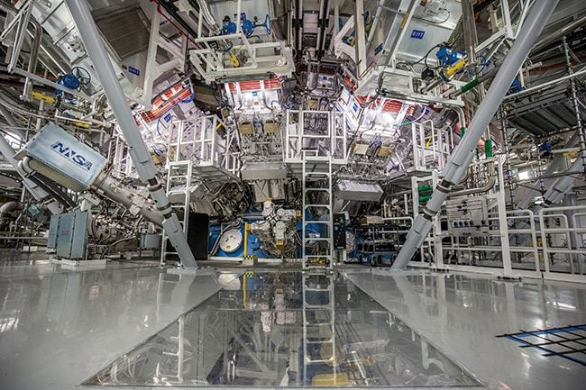
2. A December 2022 experiment at the National Ignition Facility in California achieved net energy from fusion for the first time. The target chamber, shown here, directs 192 lasers onto a 2-millimeter spherical target holding the fusion fuel. Courtesy: Lawrence Livermore National Laboratory

The experiment on NIF delivered 2.05 MJ of laser energy to a fusion target, igniting a reaction that produced 3.15 MJ of fusion energy. While the inertial fusion approach used on NIF is different from the magnetic fusion technology on JET, it established that net energy is possible and paves the way toward future developments. (It’s important to understand that “net energy,” which physicists refer to here as “target gain,” includes only the energy delivered to and produced by the target. It does not include the energy consumed by NIF as a whole, which is about two orders of magnitude larger. In general, achieving electricity generation from inertial fusion is believed to be further away than with magnetic fusion.)

Private Fusion Funding
Fusion research in the private sector is not new. Companies such as General Atomics have been working with the Department of Energy (DOE), and the Atomic Energy Commission before that, to develop practical fusion energy since the 1950s (Figure 3). What changed in the early 2020s was a flood of investment from venture capital (VC) firms, private investors, and other entities in a rapidly expanding array of start-ups pursuing fusion energy. Cumulative investment in private fusion since 2001 stood at $1.5 billion at the end of 2020. According to figures from the Fusion Industry Association (FIA), that number surged to $2.03 billion at the end of 2021, and then leapt again to $4.8 billion at the end of 2022.
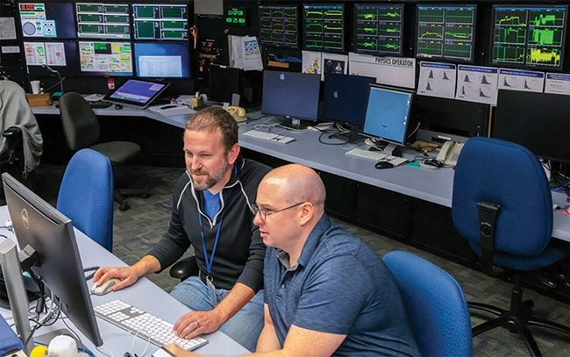
3. The Department of Energy’s DIII-D National Fusion Facility in San Diego, operated by General Atomics, is the largest fusion research center in the U.S. Researchers at DIII-D primarily explore the scientific basis for the tokamak approach to fusion energy. Courtesy: General Atomics

The diversity of investors is also striking. They include individuals like Bill Gates and Jeff Bezos, prominent VC firms like Breakthrough Energy Ventures and Y Combinator, tech firms such as Google, sovereign wealth funds, and even fossil fuel companies like Shell and Chevron [Cenovus]. This degree of confidence in fusion is remarkable given where the industry stood just five years ago.
The investments are not equally distributed, however. Though the number of private fusion firms has also surged, only seven of them report total funding of more than $200 million, and the large majority of new investment in 2022 went to just two firms, Commonwealth Fusion Systems (CFS) in Cambridge, Massachusetts, and Everett, Washington–based Helion Energy.
CFS leading the funding race is not surprising, as it claims to be the closest to building a net-energy magnetic fusion device, a tokamak called SPARC. In 2021, CFS completed a prototype high-temperature superconducting magnet for SPARC that achieved a peak field strength of 20 Tesla.
The SPARC device, a collaboration between CFS and the Massachusetts Institute of Technology, will have 18 similar magnets. SPARC is currently under construction at a site outside Boston, with initial operations planned for 2025 (Figure 4). CFS predicts that SPARC will achieve net energy shortly thereafter.
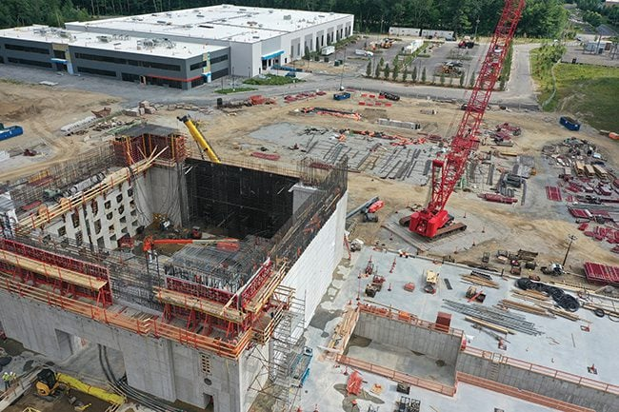
4. This September 2022 photo shows the Commonwealth Fusion Systems (CFS) site in Massachusetts, with the partially finished SPARC facility at lower left. Courtesy CFS

Despite these advances, the investment market for fusion cooled off in late 2022 and 2023 as sharply rising interest rates reduced investor interest in cutting-edge technology fields like fusion. At least one fusion firm is reported to have cancelled a planned funding round. Meanwhile, some of the more established firms have begun seeking partnerships with larger companies that could have applications for fusion.

Increased Government Support
The past several years have also seen a dramatic increase in government attention to fusion energy, though the genesis of this process came in the 2010s. In 2018, the DOE, through its Fusion Energy Sciences Advisory Committee (FESAC), set in motion a roadmap to develop a strategic plan for its fusion energy activities.
The plan that emerged in late 2020 called for the U.S. (among other recommendations) to begin a design and development process that would place the first pilot fusion power plant (FPP) on the grid no later than the 2040s. Because of the wide range of scientific, engineering, and sociopolitical challenges this would implicate, the plan envisioned a large-scale collaborative effort across government, academia, and industry. [reference 4 scenarios developed by UEROfusion]
The FESAC plan was followed in early 2021 by another report—also requested by the DOE—from the U.S. National Academies of Sciences, Engineering, and Medicine (NASEM). That report called for a similar effort that would deliver an operating FPP in the 2035–2040 timeframe. It also recommended that the DOE move forward in forming and funding public-private partnerships to develop conceptual and engineering designs that could bring fusion to commercial viability. The NASEM report was notable in that it engaged the electric utility industry and the Nuclear Energy Institute, while also involving several nuclear utilities in the report work.
Then, in March 2022, the Biden administration held a White House summit on fusion energy that was attended by a wide range of representatives from the public and private fusion communities. At the summit, the administration announced that it was developing “a bold decadal vision to accelerate fusion” and make it a key part of the path to net-zero emissions by 2050.
Secretary of Energy Jennifer Granholm said at the time, “We believe we are making great progress, but it’s going to take time to get fusion commercialized. It would be amazing if fusion were a part of what I call the silver buckshot of a clean energy future.”
Congressman Don Beyer (D-Va.), chair of the bipartisan Fusion Energy Caucus, added, “We can successfully forge a path to fusion energy. Fusion is the holy grail of clean energy technologies, and fusion has the potential to lift more citizens of the world out of poverty than anything since the invention of fire. We need a bicameral, bipartisan—in fact, I would argue non-partisan—effort on fusion energy. We can work together to get this done.”
Working from these recommendations, the DOE released a funding opportunity in September 2022 for a milestone-based fusion development program. The milestone program envisioned teams composed of private industry, academia, and the U.S. national labs, with the federal government providing up to 50% cost-share to deliver a conceptual design for an FPP that could begin operation in the 2030s.
Applications for the program were due in December 2022, and the DOE is expected to make decisions on the winning proposals in the spring of 2023. A survey conducted by the FIA indicates that applications were well in excess of current appropriations, with as much as $150 million requested from the $50 million opportunity. Meanwhile, the 2024 White House budget request, released in March, asks for $130 million for the program.
Overseas, the UK is also moving boldly forward with several similar initiatives. The first, the Fusion Demonstration Plant (FDP) announced in 2021, will house a device built by Canadian private fusion company General Fusion at the Culham lab site. General Fusion and UKAEA signed a cooperative agreement in 2022 to advance a range of fusion technologies at Culham, and construction of the FDP is expected to begin later in 2023.
A second, more ambitious program, the Spherical Tokamak for Energy Production (STEP), is being led by UKAEA. The program is intended to demonstrate net electricity from fusion, develop operational and maintenance data, and demonstrate potential to breed tritium for fuel. Unlike JET and ITER, which use conventional tokamak plasmas, STEP will be a spherical tokamak. This shape is thought to potentially improve efficiency of the magnetic field and reduce plant cost. A site for STEP has been selected in northeast England, and the first phase of the program is underway with the goal of producing a conceptual design by 2024.
Meanwhile, in China, design and engineering work on the Chinese Fusion Engineering Test Reactor (CFETR) has continued, with recent papers and presentations suggesting that Chinese researchers have made significant progress toward construction and operation. CFETR is the largest currently planned fusion pilot plant, with a projected thermal output of 2 GW (electric output will likely be around 500 MW). Full operation is planned for 2035.

Regulatory Challenges
Beyond the engineering and financial issues, fusion will also need a regulatory framework. Under the Atomic Energy Act, the Nuclear Regulatory Commission (NRC) has jurisdiction over fusion. However, both the industry and NRC agree that the current framework designed for fission reactors is not appropriate for fusion power plants.
Congress, via the 2019 Nuclear Energy Innovation and Modernization Act, has directed the NRC to establish a framework for fusion by the end of 2027. The main question is whether fusion should be regulated under Title 10 Part 53 of the Code of Federal Regulations (10 CFR 53) as a “utilization facility” similar to fission reactors, under 10 CFR 30 relating to generation of by-product material, or some hybrid of the two. Since fusion energy does not involve the use of any “special nuclear material” (that is, fissionable uranium or plutonium), the industry is nearly unanimous in seeking regulation under the by-product approach. The source term for fusion is primarily the tritium fuel, with the remainder being neutron-activated reactor components.
The NRC has held several meetings and workshops over the past three years to gather information and discuss the issues with industry representatives. In January 2023, NRC staff released a draft assessment recommending the hybrid approach based on 10 CFR 30. Exactly what this will look like is not yet clear, but the fusion industry is cautiously optimistic.
Meanwhile, the UKAEA is a few steps ahead of the NRC. In June 2022, the UK government announced that pilot FPPs in the UK will be regulated under the existing framework for fusion research facilities, such as JET, rather than under regulations for fission plants. The actual regulations will be developed via engagement with the industry over the next two to three years.

ITER Advances—and Setbacks
The massive ITER experiment under construction in southern France was envisioned as the first fusion device to achieve net energy. Whether or not one of the private fusion companies gets there first, ITER will be a critical resource for fusion research at reactor scale. Major construction has continued, with several key milestones reached, and important components successfully completed and delivered.
These include several sections of the main vacuum vessel that will contain the fusion plasma, and two of the six modules for the Central Solenoid (CS), the massive electromagnet that will power the fusion reaction. The CS is being manufactured by General Atomics, and the last of six modules should be completed within the next year.
Unfortunately, there have also been key setbacks. The COVID-19 pandemic caused a significant slowdown in both site construction and component manufacturing for over a year. Then, in January 2022, the French Nuclear Safety Authority (ASN) ordered a halt to assembly of the vacuum vessel after finding weld defects in the two sections that had been delivered up to that point (Figure 5). Further investigation determined that they had been damaged during shipment from South Korea. In addition, ASN found that the radiation shielding around the vessel was inadequate, and a correction could cause the vessel to exceed the design weight of the building foundation.
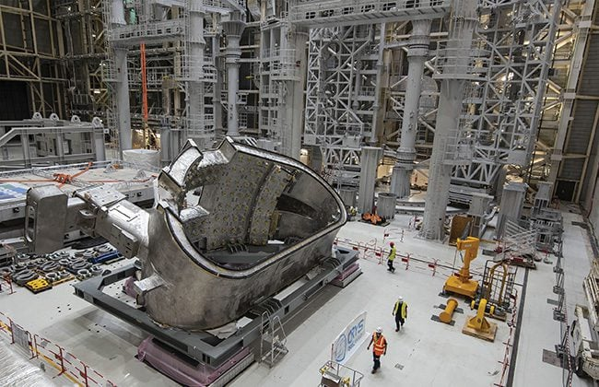
5. The first of nine sections of the massive vacuum vessel that will contain the fusion plasma in the ITER machine was delivered in late 2020. In early 2022, welding defects were discovered that halted further assembly. Courtesy ITER

First plasma operations at ITER were once planned for 2025. Italian scientist Pietro Barabaschi, who became ITER director-general in 2022 after the death of Bernard Bigot, told French media in January 2023 that start-up has likely slipped by a year or more. However, Barabaschi also said he believed the lost time could be made up, and full operations could still begin in 2035 as scheduled.

Future Outlook
The significant increase in public and private investment in fusion energy, as well as the recent scientific and technical advances, have reset expectations for many industry observers. The large number of projects working in parallel suggest that net energy could potentially be achieved via magnetic fusion in the late 2020s, which would conveniently coincide with the forthcoming NRC regulatory framework. Should that occur, it is likely that funding will be available for the first FPPs, which could come online as soon as the early 2030s.
—Thomas W. Overton is senior strategic development specialist with General Atomics in San Diego, California.

