
Is Alberta’s Public Procurement Broken? - May/June 2018
Executive Summary
Public procurement – the engagement of non-government resources, involves the administration of $Billions engaging hundreds of contractors, thousands of jobs and is central to every level of government. It is almost as core to the Alberta economy as the oil sands, and as such the frequent subject of auditor reports. The Alberta Council of Technologies Society (ABCtech) conducted an On-line survey in May 2018 to learn about the practice and objectives of public procurement in Alberta. The views of contractors and administrators – their expectations and levels of satisfaction, comments and recommendations, were solicited from among those in ABCtech’s directory of individuals sharing an interest in the impact of emerging technologies.
Sample profile. The sample includes few administrators (12%) and is comprised mainly of public procurement contractors: urban, small-business contractors that are moderately reliant on provincial contracts up to $100,000. They do not have full-time resources dedicated to public bidding. Most are familiar with information and management services and somewhat less with construction, education and research. Most are familiar with provincial and municipal procurement processes and trade agreements. A majority expect to increase their involvement in bidding on government contracts.
Public Procurement Practices. The most important features and with considerable gaps in what is expected vs received by contractors in the practice of public procurement are the features that have a direct impact on bidding – timeliness and bidding/evaluative criteria. Features of less importance are those that are viewed as the objectives of government and biasing the achievement of Value for Money – Incentives for social and economic development and innovation. Gaps are greatest among infrastructure contractors with an interest in Construction, Transportation, Engineering also Communications. The features and comments of contractors provide insight into differences among contractors. The current uncertainty in negotiation of trade agreements may by affecting the expectations of contractors indicating decreasing interest in public procurement - particularly among the Calgary Region’s small businesses contractors.
Public Procurement Objectives. Contractors and Administrators align in their disagreement with the objectives of public procurement. The Disaster Recovery objective is the only exception. Otherwise, Administrators rate highest government’s stated objectives of Innovation and Vision & Leadership, and Effectiveness. Contractors disagree, including a very low rating for the objective of Effectiveness: Government procurement and project management are well aligned. That is, deliverables are on-time, on-budget, and as specified. Otherwise, while rated higher than Contractors, Administrators support is weak for the other objectives – particularly Value for Money, that both rate lowest. Of concern must be the generally low ratings by both Administrators and Contractors for the prime objectives of public procurement: Value for Money, Transparency, and Overall. The low agreement and very high disagreement by Contractors with all objectives - other than Disaster Recovery, is consistent for most Contractor features with the possible exception of size. The poor rating for the objectives of Value for Money and Transparency is highest for larger organizations. The comments reviewed indicate that the prime issues are with waste not corruption or fraud.
Recommendations. The broad dissatisfaction and pointed gaps in public procurement practices are evident. Support is weak for the associated objectives. Respondent comments and recommendations reinforce the Report’s several recommendations:
- Establish Oversight. Establish standard expectations and expect all bidders to complete a simple anonymous evaluation of the procurement process accompanying each bid..
- Continuous Improvement. Engage a 3rd party to conduct an audit of the public procurement system – it’s practices and objectives engaging contractors and administrators. Target the gaps and follow-up on improvements annually. Propose recommendations and standards.
- Engage Industry. Review all public procurement practices with the intent of increasing small business engagement, promoting innovation, and incenting collaboration/partnering.
- Special Consideration for Emerging Technologies. Emerging technologies are challenging all public procurement practitioners to remain up-to-date on the latest innovations. This is particularly true in information management affecting all industries and all departments - healthcare in particular – given the extraordinary costs and waste reported in the development of health information systems. The rate of change is so great as to make the task of encouraging innovation while also containing costs, managing risk and avoiding waste.
- Listen. The Government of Alberta should establish an Industry Advisory reporting to the Minister of Service Alberta with responsibility to file an annual report with the Minister and the public on the status of public procurement.
- Learn. Host an annual conference for stakeholders to be exposed to best practices in public procurement
Action is warranted. The economy is changing – the digital age and emerging technologies are accelerating change. Organizations must adapt; to be nimble and responsive is essential. Public services secured through contracting that are sub-standard and inefficient are unacceptably wasteful. Every $Billion of waste by the Government of Alberta, for example, equates to over $222 per citizen. The socialization of public services is NOT the answer, nor are policies of “Buy Alberta!” What is needed is what is already promised in policy: Transparency, Value for Money, and Effectiveness. Contractors agree, And using public procurement as a blunt instrument for social engineering is offensive and contrary to securing good products and services – preference is bias, creating discord and resentment. What is inferior shouldn’t get preference. What isn’t inferior, shouldn’t need preference.

Table of Contents Page
Executive Summary …………………………………………………………………………………………………………………………………………. 1
Table of Contents ..…………………………………………………………………………………………………………………………………………… 3
Introduction ………………………………………………………………………………………………………..……………..………………….………. 4
- Contractors – Their Profile and Interests ………………………………………………………………….………………………….…….. 6
- Assessing Alberta’s Public Procurement Practices …………………………………….…………………………………………….….. 10
- First, what is most important for Alberta’s contractors in public procurement? ……………………………….….. 10
- Next, do contractors differ in their assessment of public procurement practices? …….…………………………... 11
- LOCATION ……………………………………………………….………………… 11
- INDUSTRY ..…………………………………………………………………...….. 13
- LEVELS OF GOVERNMENT ….………………………………………………. 16
- ENGAGING CONTRACTORS …………………………………….………….. 18
- Assessing Alberta’s Public Procurement Objectives ………………………………..…………………………………………...…….. 23
- First, how do administrators and contractors view the objectives of public procurement? …………………... 23
- Next, how do Contractors differ in their views of public procurement objectives? .………………………………… 24
  - LOCATION ……………………………………………………….………………… 24
  - INDUSTRY ..…………………………………………………………………...….. 26
  - LEVELS OF GOVERNMENT ….………………………………………………. 27
  - CONTRACTOR SUPPORT ………………………………………...………….. 28
CONTRACTOR’S COMMENTS RE: THE OBJECTIVES …………….. 30
- Recommendations and the Conclusion …………………………………………………………………………………………………..……. 33
Conclusion …………………………………………………………………………………………………………………………………………………….40

Introduction
Billions of dollars are spent annually by various levels of government in the purchase of supplies and services in Alberta. The public expenditure represents both a significant economic opportunity and the risk of waste, fraud and corruption. Procurement policy is shaped by trade agreements and regulations governing fair trade. The practice itself is the by-product of a make-or-buy decision, and an assessment of whether competition in the private sector is adequate to govern costs and standards. Independent audit reports are employed to provide independent oversight.
The Alberta Council of Technologies Society exists to advance the commercialization of emerging technologies as a contributor to diversification of the province’s economy. Public procurement continues to be of interest to our 20,000 followers comprised of a diverse array of industry and public sector interests, innovators and regulators, taxpayers and policy influencers, contractors and administrators. Our interest in public procurement has recently increased.
Public procurement is being exposed to increased public scrutiny as associated issues converge:
- Interprovincial trade and the renegotiation of trade agreements
- Debate on the role of governments in diversifying the Alberta economy
- Introduction of policies and practices to stir innovation and social justice objectives
- Audit reports of extraordinary waste in the procurement for example of data management systems

The Council elected to conduct one of the first external, independent assessments of public procurement in Alberta. We were particularly interested in obtaining the perspective of contractors, given the interest expressed by governments in heightening innovation. In May we canvassed our followers soliciting the interest of contractors and procurement administrators. The On-line survey posed a series of questions about the practice and objectives of public procurement by the federal, provincial and municipal governments in Alberta. The survey’s objectives were several, to learn about:

- The expectations of contractors, how they vary, and whether they are being met
- The policy objectives of public procurement and whether they are being met
- Differences between contractors and administrators, industries/professions, and geographic areas of the province
- Recommendations for improving public procurement both in terms of its practice and in terms of achieving it’s objective(s)

We assumed that the interests of administrators and contractors would be reasonably aligned as they are the prime partners in the system. We incorporated two questions, the answers to which served as primary reference points for the study: 1. Value for money and 2. Transparency - free from waste, fraud and corruption.

The summary and discussion of results are organized into sections: A. Contractors – Their Profile and Interests, B. Assessing Pubic Procurement Practices, C. Assessing Public Procurement Objectives and D. Recommendations and the Conclusion. Note. The identity of respondents is confidential. However, the data is open for scrutiny should others be interested in conducting and sharing their analysis.
A. Contractors – Their Profile and Interests
Of the 92 respondents, most (88%) were corporate contractors with a few (12%) administrators. Most of the contractors and administrators were from the Edmonton ( 72% and 64%) and Calgary (21% and 27%) Regions with few from outside urban Alberta (7% and 9%).

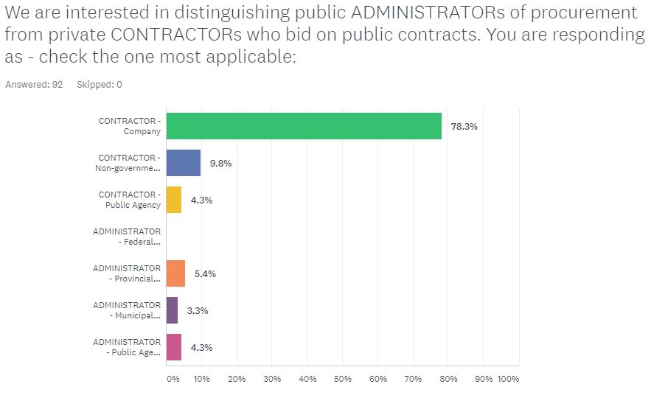 |   Contractors N = 81  Northern Alberta 2%  Edmonton Region 72%  Central Alberta 5%  Calgary Region 21%  Southern Alberta 0%  Administrators N = 11  Northern Alberta 0%  Edmonton Region 64%  Central Alberta 9%  Calgary Region 27%  Southern Alberta 0%

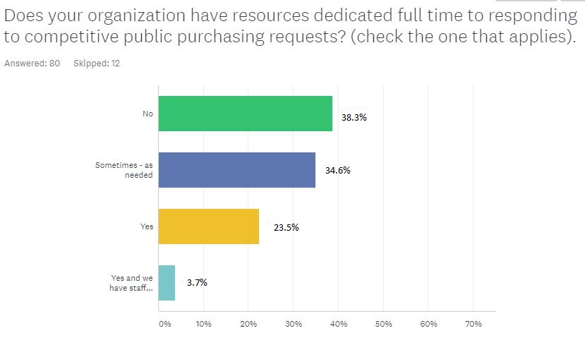
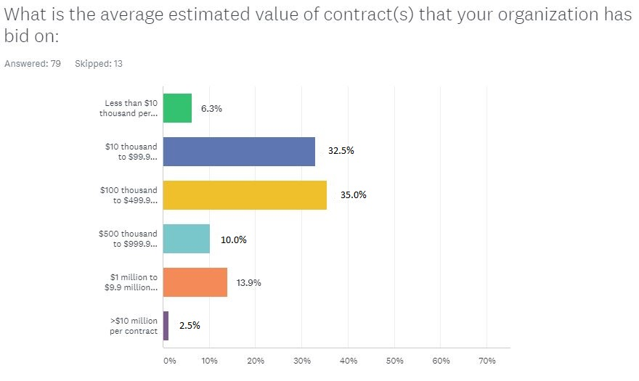

The contractor’s typical contract bid (75%) was $100,000 or less – a small business with 74% having no dedicated resources for responding to
Competitive Provincial (3.8: 5.0) and municipal (3.1: 5.0) procurement purchasing requests.

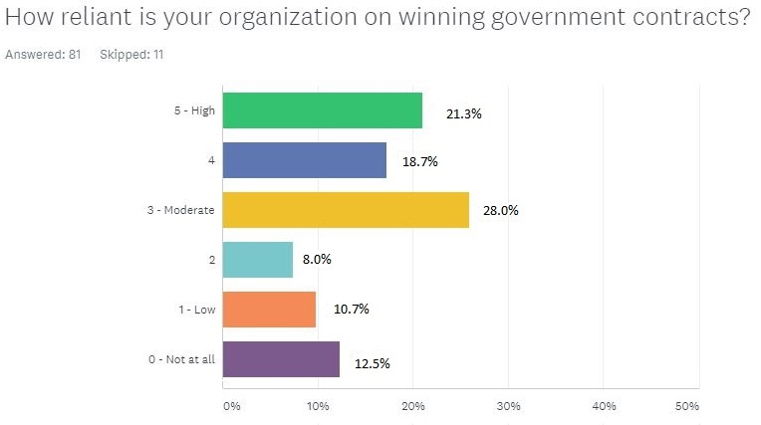
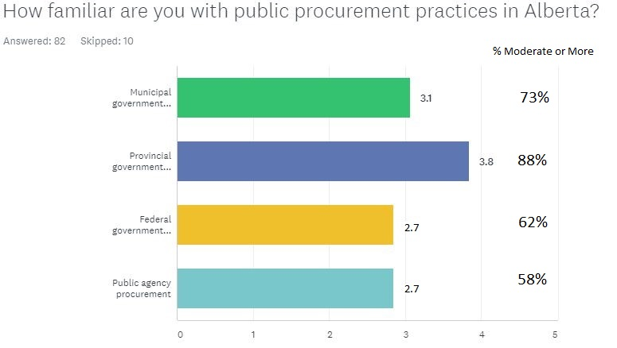

Eighty-eight percent of contractors are moderately or more familiar with provincial procurement practices; they are most familiar with public processes in Alberta. More than 2/3^{rds} of the contractors rely moderately or more on government contracts.
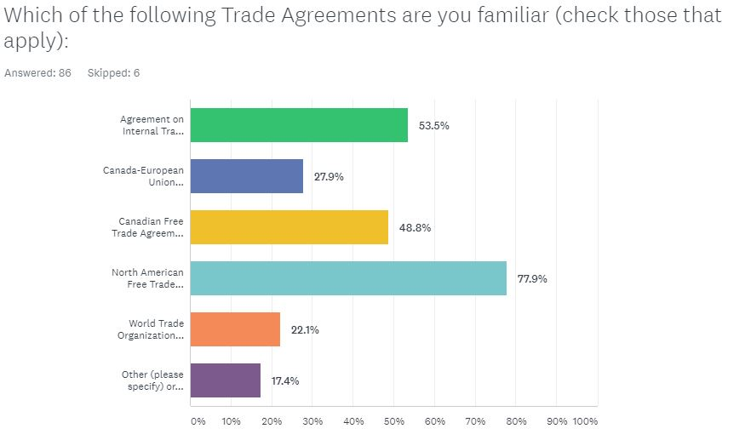
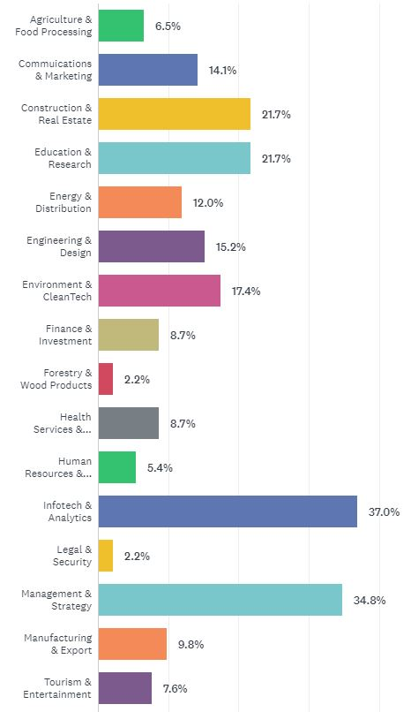
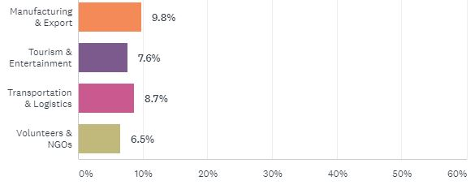


The industries most familiar to contractors engaged in public procurement are: Infotech & Analytics (37%) and Management & Strategy (35%) followed by Construction & Real Estate and Education & Research (both 22%). Familiarity is highest with the North American Free Trade Agreement (77%). Several (10%) also commented on their familiarity with the New West Partnership Trade Agreement.
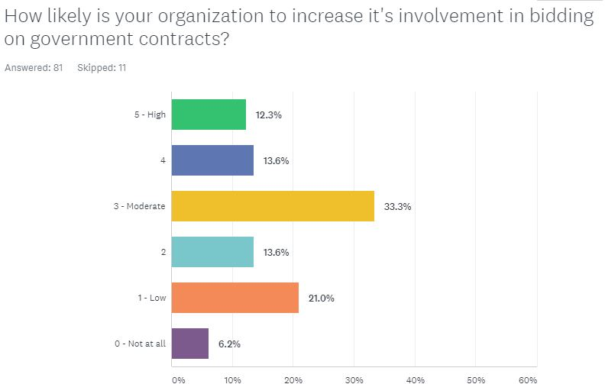

Almost 60% of the contractors expect to increase their involvement in bidding on government contracts.
SUMMARY
The sample includes few administrators and is comprised mainly of public procurement contractors: urban, small-business contractors, that while moderately reliant on provincial bidding up to $100,000, they do not have full-time resources dedicated to public bidding. Most are familiar with information and management services and somewhat less with construction, education and research. Most are familiar with provincial and municipal procurement processes and trade agreements. A majority expect to increase their involvement in bidding on government contracts.
* * *
The next Section B. is comprised of an evaluation of various practice features of public procurement in Alberta from the perspective of contractors.

B. Assessing Alberta’s Public Procurement Practices
For assessing the practice of public procurement in Alberta, we asked respondents to rate their experience with 13 practice features in terms of what is important and expected AND what is received and satisfaction. For discussion, each feature is analyzed and presented independently:
- Rating each of the 13 practice feature on a scale from 5 – High to 3 – Moderate to 1 – Low
- Ranking of the practice feature’s in terms of Expected-Importance vs. Received-Satisfaction
- Identifying the gap between Expected-Importance and Received-Satisfaction
- Comparing expectations and gaps with contractor’s features as identified in Section A.
- Developing a profile for contractors interested – and not, in increasing their involvement in bidding.

- First, what is most important for Alberta’s contractors in public procurement?
Practice Features – ranked below in order of Expected-Importance (E-I). Ratings are on a 5 point scale from 5 - High to 3 – Moderate to 1 – Low. Gap compares E-I with Received-Satisfaction. | Rating | Gap | Ranking  Delta*
- Reasonable timelines for bid preparation | 4.37 | 1.72 | 4
- Terms of service/supply: fair, clear, rational | 4.28 | 1.68 | 4.5
- Reasonable timelines for service/supply delivery | 4.27 | 1.24 | 8
- Ease of use and responsive: e.g.: electronic on-line communication | 4.24 | 1.68 | 2.5
- Evaluative criteria, e.g.: fair, clear, rational | 4.23 | 1.86 | 1
- Advance notice and helpful information | 4.20 | 1.88 | 3
- Reasonable pricing for labour and capital | 4.14 | 1.54 | 1
- Reasonable pre-qualifications: e.g.: insurance, location, resources, experience | 4.01 | 1.25 | 2
- Bid feedback, e.g.: timely, clear, rational | 4.00 | 1.96 | 7
10. Incentives for innovation, e.g.: technology, partnering, compensation, project management | 3.84 | 2.03 | 9
11. Clear process for change management | 3.84 | 1.39 | 2
12. Incentives for economic development e.g.: location, jobs, salary levels | 3.36 | 1.16 | -
13. Incentives for social development, e.g. race, gender, education, religion | 2.77 | 0.18 | -
Weighted Average | 3.97 | 1.47
*Ranking Delta refers to the difference between a feature’s Expected and Received rank.

- Most features assessed are rated as important. The five most important >4.00 practice features to contractors are those contributing to bid preparation: timeliness for 1. Bidding and 3. Service/supply, and criteria for 5. Evaluation and 2. Terms of service. Ease of use and responsiveness 4. is also rated high. The next four in importance - rating 4.00 or more, are also associated with bidding. The least important >1.50 interests: incentives 10, 12, 13 and 11. Change management.

- Gaps are considerable particularly for features primary to preparing a bid. The gaps between Expected-Importance and Received-Satisfaction were considerable averaging 1.47 on a 5 point scale or 30%. The largest gaps among the top five important features are: 6. Advance notice, 5. Evaluative criteria, and 1. Reasonable timelines for bid preparation. Large gaps - close to 2.00, are also apparent for several of the less important features: 10. Incentives for innovation and 9. Bid feedback.

- The features warranting attention. Contractors view the importance >4.00 and the gaps > 1.50 as considerable for most of the procurement practice features surveyed. We categorized those features associated with bid preparation as “Primary” (Yellow in the table above), and those associated with public objectives as “Secondary” (Blue).
Summary. Contractors value most the public procurement features essential to preparing bids, features that are also viewed as having the greatest gaps in what is expected and received. Those features associated with public objectives are viewed as less important though expectations are not being met for innovation.

- Next, do contractors differ in their assessment of public procurement practices?
Contractors differ from one another in a number of ways as identified in section A. In this section we assess the relevance of these characteristics in the contractors assessment of public procurement practices. For example, do contractors differ in their assessment of municipal, provincial and federal public procurement practices or based on where in the province they are located? We start with Location.

- LOCATION. Locations are aligned with the importance and gaps in primary procurement practice features. There are few respondents from Northern, Southern, and Central Alberta; we therefore merged their responses as Other.
LOCATION – Rating of Expected-Importance vs Received-Satisfaction. Ratings are on a 5 point scale from 5 - High to 3 – Moderate to 1 – Low. | Edmonton N=53 | Calgary N=16 | Other  N=5 | Weighted  Average
- Reasonable timelines for bid preparation | 4.36 | 4.31 | 4.80 | 4.37
- Terms of service/supply: fair, clear, rational | 4.31 | 4.06 | 4.60 | 4.28
- Reasonable timelines for service/supply delivery | 4.36 | 3.93 | 4.20 | 4.27
- Ease of use and responsive: e.g.: electronic on-line communication | 4.26 | 4.06 | 4.40 | 4.24
- Evaluative criteria, e.g.: fair, clear, rational | 4.17 | 4.33 | 4.40 | 4.23
- Advance notice and helpful information | 4.09 | 4.38 | 4.60 | 4.20
- Reasonable pricing for labour and capital | 4.15 | 3.93 | 4.40 | 4.14
- Reasonable pre-qualifications: e.g.: insurance, location, resources, experience | 4.15 | 3.50 | 4.20 | 4.01
- Bid feedback, e.g.: timely, clear, rational | 4.06 | 3.64 | 4.20 | 4.00
10. Incentives for innovation, e.g.: technology, partnering, compensation, project management | 3.68 | 4.13 | 4.40 | 3.84
11. Clear process for change management | 3.79 | 4.00 | 3.60 | 3.84
12. Incentives for economic development e.g.: location, jobs, salary levels | 3.23 | 3.71 | 3.80 | 3.36
13. Incentives for social development, e.g. race, gender, education, religion | 2.63 | 1.00 | 2.40 | 2.27
Weighted Average | 3.94 | 3.71 | 4.15 | 3.93
Observations:
- Contractors in Calgary Region on average have lower ratings and those in the Other locations, the higher ratings.
- The Regions generally align on the importance >4.00 and ranking of each of the primary practice features, with the secondary features generally rated below 4.00.
- Exceptions for Calgary and Other are the >4.00 ratings for 10. Incentives for innovation and for Calgary the <4.00 rating for 8. Reasonable pre-qualifications and 9. Bid feedback.
- Regions are aligned that Incentives for social development 13. are the least important.

LOCATION – Gaps in Expected-Importance vs Received-Satisfaction. Ratings are on a 5 point scale from 5 - High to 3 – Moderate to 1 – Low. | Edmonton N=53 | Calgary N=16 | Other N=5 | Weighted  Average
- Reasonable timelines for bid preparation | 1.78 | 2.40 | 1.38 | 1.88
- Terms of service/supply: fair, clear, rational | 1.55 | 2.20 | 1.81 | 1.68
- Reasonable timelines for service/supply delivery | 1.40 | 0.80 | 0.87 | 1.24
- Ease of use and responsive: e.g.: electronic on-line communication | 1.54 | 2.20 | 1.38 | 1.68
- Evaluative criteria, e.g.: fair, clear, rational | 1.81 | 2.20 | 1.87 | 1.86
- Advance notice and helpful information | 1.73 | 2.13 | 2.40 | 1.88
- Reasonable pricing for labour and capital | 1.73 | 1.00 | 1.07 | 1.54
- Reasonable pre-qualifications: e.g.: insurance, location, resources, experience | 1.33 | 2.60 | 0.50 | 1.35
- Bid feedback, e.g.: timely, clear, rational | 1.87 | 2.20 | 2.00 | 1.96
10. Incentives for innovation, e.g.: technology, partnering, compensation, project management | 1.78 | 2.60 | 2.56 | 2.03
11. Clear process for change management | 1.25 | 1.20 | 1.86 | 1.39
12. Incentives for economic development e.g.: location, jobs, salary levels | 0.97 | 1.80 | 1.57 | 1.12
13. Incentives for social development, e.g. race, gender, education, religion | 0.00 | -0.20 | 1.00 | 0.18
Average | 1.44 | 1.82 | 1.54 | 1.47
Observations:
- Gaps prevail across all practice features with the possible exception of 13. Incentives for social development, that is also viewed as least important.
- The average gap was greatest among the Region’s contractors for those in the Calgary Region (1.82) and least for those in the Edmonton Region (1.44).
- Large gaps >1.50 are apparent on the primary practice features with the exception of 3. Reasonable timelines for service/supply delivery.
- All three locations also have large gaps>1.50 in 6. Advance notice, 9. Bid feedback, and 10. Incentives for innovation.
- Variation is not apparent between locations with the possible exception of contractors in the Calgary Region that cite a very large gap (2.60) in 8. Reasonable pre-qualifications and the Edmonton contractors that cite a large gap in 7. Reasonable pricing for labour and capital.
Summary. Contractors across the three locations are in general agreement that primary public procurement features – those directly impacting bidding, are the most important and also with large gaps between what is expected and received. Large gaps are also cited for most other procurement features including incentives. While incentives are among the least important, they - particularly incentives for innovation, are cited as having a large gap by contractors in all three locations. Inconsistency is apparent between locations in pre-qualifications to bid (Calgary) and in pricing for labour and capital (Edmonton).
- INDUSTRY. Primary procurement features are important to most industries, with the greatest gaps identified by infrastructure industries
Contractors were asked to identify up to three the industries engaged in public procurement that they were familiar. Their rating of each feature was assigned to each industry they identified. Caution, there is considerable variation in the number of observations for each industry
INDUSTRY - Rating of Expected-Importance vs Received-Satisfaction |  | Public Procurement Practice features
 | N | 1 | 2 | 3 | 4 | 5 | 6 | 7 | 8 | 9 | 10 | 11 | 12 | 13 | Weighted  Average
Agriculture & Food Processing | 5 | 4.40 | 3.00 | 3.80 | 3.40 | 3.40 | 3.20 | 3.80 | 4.20 | 2.80 | 3.00 | 3.20 | 2.80 | 3.20 | 3.40
Communications & Marketing | 8 | 4.38 | 4.63 | 4.13 | 4.50 | 4.25 | 3.63 | 4.13 | 4.00 | 4.38 | 4.00 | 2.63 | 3.38 | 4.50 | 4.04
Construction & Real Estate | 16 | 4.13 | 4.31 | 4.19 | 4.00 | 4.27 | 3.88 | 4.50 | 4.33 | 4.20 | 3.69 | 3.27 | 3.81 | 3.94 | 4.04
Education & Research | 17 | 4.06 | 4.06 | 3.59 | 4.29 | 4.18 | 3.56 | 4.19 | 3.76 | 4.18 | 3.65 | 3.29 | 3.13 | 3.63 | 3.81
Energy & Distribution | 11 | 4.73 | 4.64 | 3.55 | 4.36 | 4.36 | 3.70 | 3.80 | 3.78 | 4.40 | 4.18 | 3.40 | 4.33 | 4.11 | 4.10
Engineering & Design | 9 | 4.11 | 4.56 | 4.22 | 4.11 | 4.22 | 4.11 | 4.22 | 4.11 | 4.11 | 4.00 | 2.67 | 3.33 | 4.00 | 3.98
Environment & CleanTech | 15 | 4.33 | 4.13 | 3.47 | 4.07 | 4.13 | 3.71 | 3.93 | 3.77 | 4.00 | 4.00 | 3.00 | 3.46 | 3.69 | 3.82
Finance & Investment | 6 | 3.67 | 3.67 | 3.33 | 3.17 | 3.33 | 2.50 | 3.33 | 3.40 | 3.20 | 3.50 | 3.00 | 3.40 | 3.00 | 3.27
Forestry & Wood Products | 1
Health & BioTech | 7 | 4.57 | 4.57 | 4.29 | 4.57 | 4.57 | 4.00 | 4.43 | 4.71 | 4.43 | 3.71 | 2.83 | 3.71 | 4.43 | 4.20
Human Resources & Development | 6 | 3.83 | 4.33 | 3.50 | 4.00 | 3.83 | 3.00 | 3.67 | 3.50 | 4.00 | 3.00 | 2.56 | 3.17 | 3.67 | 3.56
Infotech & Analytics | 27 | 4.30 | 4.44 | 4.19 | 4.44 | 4.44 | 3.89 | 4.19 | 4.07 | 4.44 | 4.04 | 4.00 | 3.44 | 4.22 | 4.05
Legal & Security | 1
Management & Strategy | 26 | 4.31 | 4.46 | 4.19 | 4.35 | 4.42 | 4.15 | 4.23 | 4.42 | 4.62 | 3.96 | 2.31 | 3.19 | 4.27 | 4.07
Manufacturing & Export | 10 | 4.40 | 4.20 | 4.10 | 4.10 | 4.22 | 4.00 | 4.30 | 3.89 | 4.00 | 4.30 | 3.67 | 4.60 | 4.60 | 4.18
Tourism & Entertainment | 5 | 3.80 | 4.60 | 4.00 | 3.80 | 4.40 | 3.40 | 4.20 | 4.00 | 4.60 | 4.00 | 3.00 | 3.20 | 4.60 | 3.97
Transportation & Logistics | 6 | 4.33 | 4.33 | 4.67 | 4.00 | 4.33 | 4.50 | 4.17 | 4.50 | 4.67 | 4.33 | 3.00 | 3.83 | 4.33 | 4.23
Volunteers & NGOs | 5 | 3.80 | 3.40 | 2.60 | 3.40 | 4.00 | 3.00 | 3.75 | 3.40 | 3.20 | 2.40 | 3.20 | 2.00 | 2.75 | 3.15
Weighted Average |  | 4.24 | 4.28 | 3.93 | 4.16 | 4.23 | 3.77 | 4.12 | 4.05 | 4.20 | 3.82 | 2.90 | 3.46 | 4.02 | 3.94
Observations
- Legal and Forestry are not included in the analysis due to the small sample size.
- Most procurement features are important >4.00 to all industries with the least important <3.00 11. Change management and possibly 12. Incentives for economic development..
- The industries viewing incentives as important >4.00 are: Manufacturing, Transportation, Energy, and Infotech with Communications rating highest 13. Incentives for social development.
- The industry rating incentives as least important <3.00 is Volunteers & NGOs.
INDUSTRY – Gaps in Expected-Importance vs Received-Satisfaction |  | Public Procurement Practice features
 | N | 1 | 2 | 3 | 4 | 5 | 6 | 7 | 8 | 9 | 10 | 11 | 12 | 13 | Weighted  Average
Agriculture & Food Processing | 5 | 1.00 | 0.00 | 1.00 | 0.40 | 0.40 | 0.95 | 1.30 | 1.00 | -0.4 | 0.80 | 0.40 | -.20 | -.30 | 0.49
Communications & Marketing | 8 | 2.38 | 2.38 | 2.13 | 2.25 | 2.00 | 1.50 | 1.63 | 1.50 | 2.13 | 2.50 | -.38 | 1.63 | 3.00 | 1.89
Construction & Real Estate | 16 | 1.77 | 1.96 | 1.54 | 1.57 | 2.11 | 1.95 | 1.71 | 1.87 | 1.82 | 2.12 | 0.65 | 1.67 | 1.72 | 1.73
Education & Research | 17 | 1.26 | 1.46 | 0.85 | 2.03 | 1.71 | 1.63 | 1.90 | 1.30 | 1.64 | 1.65 | 0.43 | 0.84 | 1.70 | 1.42
Energy & Distribution | 11 | 2.18 | 1.91 | 0.82 | 1.82 | 2.00 | 1.40 | 1.10 | 1.00 | 1.6 | 2.82 | 0.80 | 1.56 | 1.44 | 1.57
Engineering & Design | 9 | 2.11 | 2.27 | 1.65 | 1.11 | 1.65 | 1.97 | 0.94 | 1.54 | 2.25 | 2.71 | 0.38 | 1.76 | 2.29 | 1.74
Environment & CleanTech | 15 | 1.98 | 1.70 | 0.90 | 1.64 | 1.56 | 1.56 | 1.47 | 0.94 | 1.23 | 2.21 | 0.08 | 0.71 | 1.28 | 1.33
Finance & Investment | 6 | 1.83 | 1.33 | 0.33 | 0.50 | 1.17 | 0.67 | 0.50 | 1.00 | 0.60 | 1.50 | 0.00 | 0.80 | 1.20 | 0.88
Forestry & Wood Products | 1
Health & BioTech | 7 | 2.14 | 1.57 | 0.29 | 1.29 | 1.14 | 1.0 | 1.29 | 1.57 | 1.00 | 2.14 | -.43 | 1.29 | 1.43 | 1.21
Human Resources & Development | 6 | 1.50 | 0.67 | 0.17 | 1.50 | 0.50 | 0.80 | 0.67 | 0.83 | 0.83 | 0.50 | -.67 | 0.50 | 1.33 | 0.70
Infotech & Analytics | 27 | 2.05 | 1.80 | 1.44 | 1.87 | 1.87 | 1.42 | 1.29 | 1.68 | 2.12 | 2.22 | 0.23 | 1.30 | 2.33 | 1.66
Legal & Security | 1
Management & Strategy | 26 | 1.96 | 1.69 | 1.35 | 1.54 | 1.54 | 1.50 | 1.08 | 1.69 | 2.27 | 2.12 | -.08 | 1.27 | 2.54 | 1.57
Manufacturing & Export | 10 | 2.20 | 1.30 | 0.60 | 1.54 | 0.67 | 1.70 | 0.80 | 0.67 | 1.00 | 2.90 | 0.78 | 2.40 | 2.30 | 1.40
Tourism & Entertainment | 5 | 0.80 | 2.00 | 1.80 | 0.90 | 1.60 | 1.20 | 1.60 | 1.80 | 2.00 | 1.20 | 0.40 | 0.80 | 2.40 | 1.46
Transportation & Logistics | 6 | 2.50 | 2.33 | 2.33 | 1.53 | 2.17 | 2.33 | 1.50 | 1.67 | 2.83 | 2.67 | 0.67 | 1.67 | 2.33 | 2.06
Volunteers & NGOs | 5 | 0.40 | 0.40 | -.20 | 1.40 | 1.00 | 0.75 | 1.25 | 0.20 | 0.00 | 0.20 | 0.40 | -1.0 | -.75 | 0.23
Weighted Average |  | 1.89 | 1.68 | 1.13 | 1.53 | 1.60 | 1.47 | 1.27 | 1.41 | 1.69 | 2.02 | 0.24 | 1.21 | 1.93 | 1.47
Observations:
- The industry gaps in public procurement features vary considerably with the highest >1.70 in Transportation, Communications, Engineering, and Construction. The lowest <0.70 are in NGOs, Agriculture and Human Resources and possibly Forestry and Legal.
- The highest industry gap among the procurement features is for 1. Timelines for bid preparation and for secondary features: 10. Incentives for innovation and 13. Incentives for social innovation. The lowest gap <0.70 is in 11. Change management with the highest gap >1.70 in 10. Incentives for innovation, 1. Timelines for bid preparation, and 13. Incentives for social innovation.
- Expectations are met or exceeded for several features by NGOs and by several industries for 11. Change management.
Summary. Most public procurement features are viewed as important by all industries surveyed. Variations in importance may reflect objectives specific to the industry, such as the importance attributed to social development in Communications. Gaps also vary considerably between industries with the greatest gaps apparent in Alberta’s infrastructure industries of Transportation and Construction, Engineering and Communications.
- LEVELS OF GOVERNMENT. Contractors view primary procurement features as important for each level of government and public agencies. Gaps in expectations are apparent for bid feedback and incentives, particularly social development and innovation.
Contractors were asked to rate on a scale of from 5 – High to 3 – Moderate to 1 – Low and 0 – None, their familiarity with municipal, provincial and federal public procurement practices in Alberta. The following analyses portray the views of contractors who rated their familiarity as Moderate 3.00 or better with public procurement levels of government and public agencies.
LEVELS of GOVERNMENT AND PUBLIC AGENCIES – Rating of Expected-Importance vs Received-Satisfaction | Municipal  N=59 | Provincial N=71 | Federal  N=49 | Public Agency N=44 | Weighted  Average
- Reasonable timelines for bid preparation | 4.25 | 4.16 | 4.36 | 4.28 | 4.25
- Terms of service/supply: fair, clear, rational | 4.43 | 4.36 | 4.34 | 4.53 | 4.41
- Reasonable timelines for service/supply delivery | 4.16 | 4.01 | 4.17 | 4.16 | 4.12
- Ease of use and responsive: e.g.: electronic on-line communication | 4.29 | 4.20 | 4.34 | 4.30 | 4.27
- Evaluative criteria, e.g.: fair, clear, rational | 4.33 | 4.25 | 4.39 | 4.33 | 4.32
- Advance notice and helpful information | 3.91 | 3.85 | 4.04 | 3.80 | 3.90
- Reasonable pricing for labour and capital | 4.30 | 4.25 | 4.46 | 4.31 | 4.32
- Reasonable pre-qualifications: e.g.: insurance, location, resources, experience | 4.26 | 4.09 | 4.27 | 4.17 | 4.19
- Bid feedback, e.g.: timely, clear, rational | 4.38 | 4.22 | 4.39 | 4.48 | 4.35
10. Incentives for innovation, e.g.: technology, partnering, compensation, project management | 3.95 | 3.80 | 3.91 | 3.95 | 3.89
11. Clear process for change management | 2.82 | 2.81 | 2.87 | 3.00 | 2.86
12. Incentives for economic development e.g.: location, jobs, salary levels | 3.43 | 3.35 | 3.43 | 2.58 | 3.43
13. Incentives for social development, e.g. race, gender, education, religion | 4.11 | 3.94 | 4.00 | 2.26 | 4.04
Weighted Average | 4.05 | 3.95 | 4.08 | 4.08 | 4.03

Observations:
- The importance of public procurement practice features average 4.03 within a narrow range of 3.95 to 4.08. What contractors view as important- expected is consistent across each level of government and public agencies in Alberta.
- Most important >4.00 are the primary procurement features plus 9. Bid feedback and 7. Reasonable pricing and possibly 13. Incentives for Social development. Less important <3.00 for contractors with each level of government is 11. Change management and for those familiar with contracting by public agencies: Incentives for 12. Economic and 13. Social development. Such incentives may be less relevant than for the levels of government.
LEVELS OF GOVERNMENT and PUBLIC AGENCIES – Gaps in Expected-Importance vs Received-Satisfaction | Municipal  N=59 | Provincial N=71 | Federal  N=49 | Public Agency N=44 | Weighted  Average
- Reasonable timelines for bid preparation | 1.85 | 1.75 | 1.93 | 1.79 | 1.82
- Terms of service/supply: fair, clear, rational | 1.79 | 1.64 | 1.77 | 1.83 | 1.74
- Reasonable timelines for service/supply delivery | 1.41 | 1.17 | 1.49 | 1.31 | 1.33
- Ease of use and responsive: e.g.: electronic on-line communication | 1.59 | 1.48 | 1.75 | 1.57 | 1.58
- Evaluative criteria, e.g.: fair, clear, rational | 1.63 | 1.56 | 1.86 | 1.84 | 1.70
- Advance notice and helpful information | 1.33 | 1.37 | 1.65 | 1.39 | 1.42
- Reasonable pricing for labour and capital | 1.21 | 1.19 | 1.50 | 1.28 | 1.28
- Reasonable pre-qualifications: e.g.: insurance, location, resources, experience | 1.57 | 1.43 | 1.65 | 1.61 | 1.55
- Bid feedback, e.g.: timely, clear, rational | 2.02 | 1.81 | 1.97 | 2.05 | 1.95
10. Incentives for innovation, e.g.: technology, partnering, compensation, project management | 2.21 | 1.96 | 2.21 | 2.27 | 2.13
11. Clear process for change management | 0.26 | 0.21 | 0.38 | 0.43 | 0.30
12. Incentives for economic development e.g.: location, jobs, salary levels | 1.33 | 1.11 | 1.23 | 1.30 | 1.23
13. Incentives for social development, e.g. race, gender, education, religion | 2.13 | 1.86 | 1.79 | 2.04 | 1.95
Weighted Average | 1.56 | 1.43 | 1.63 | 1.59 | 1.54
Observations:
- Gaps are large >1.70 for several Secondary procurement practice features, specifically: Incentives for 10. Innovation and 13. Social development in addition to: 9. Bid feedback, 1. Timelines for bid preparation, 2. Terms of service and possibly 5. Evaluative criteria
- Gaps in what is received vs. what is expected are overall consistent – ranging +/- 0.12 between levels of government and public agencies with the province lowest.
- The smallest gaps <0.50 are consistently with public procurement practice of 11. Change management.
Summary. Contractors have a consistent view of what is important- expected as practiced by several levels of government and public agencies, namely the primary practice features. Similarly, while large, gaps are consistent though gaps are apparent in incentives for innovation and social development. Where objectives may differ – such as public agencies compared with levels of government, gaps are less apparent in what is expected and received.
- ENGAGING CONTRACTORS
In the following analysis we assembled the profile of the organizations that are most and least likely to increase their involvement in bidding on government contracts employing a scale of 5 – High, 3- Moderate, 1 – Low, 0 – Not at all. All proportions are weighted. The section concludes with a sample of comments from each group.
PROFILE –  INCREASING INVOLVEMENT IN BIDDING |  | HIGH - >3 | LOW - <3 including  0 – Not at all | MODERATE - 3
OVERALL |  | 27% | 40% | 33%
Declining interest 40% of contractors in public procurement compares with 60% moderate and expecting to increase.

LOCATION
% Edmonton Region  % Calgary Region  % Other |  | 24% | 38% | 36%
 |  | 18% | 53% | 35%
 |  | 83% | 17% | 0%
The interest of public procurement contractors in Calgary may be declining with the proportion outside Edmonton and Calgary increasing.

RELIANCE
High – 40% |  | 67% | 24% | 36%
Moderate – 28% |  | 10% | 55% | 24%
Low - 32% |  | 24% | 21% | 40%
Contractors expecting to increase their involvement in public procurement bidding (67%) are also the more reliant on winning bids (40%). Most expecting to decrease their involvement (55%) have a moderate reliance (28%). Those least likely to change – increase or decrease their involvement (40%) are among the least reliant (32%).
INDUSTRY
The top four industries familiar to public procurement contractors |  | Construction | Management | Infotech
 |  | Infotech | Communications | Management
 |  | Education | Infotech | Communications
 |  | Manufacturing | Construction | Manufacturing
Interest in bidding among contractors familiar with Manufacturing may be increasing; uncertainty is indicated among those familiar with Infotech and Construction. Decreasing interest is apparent with those familiar with Management and Communications.

GOVERNMENT familiarity > Moderate
% Municipal | 45% |  | 41% | 41%
% Provincial | 68% |  | 77% | 70%
% Federal | 32% |  | 40% | 37%
% Public Agency | 50% |  | 41% | 41%
Familiarity with public procurement practices is highest with the Provincial government for all three groups. Familiarity between groups is quite consistent, with a maximum of 9% between High and Low for contractors familiar with Provincial government and Public Agency procurement.

TRADE Agreements familiarity
NAFTA – 73% |  | 64% | 78% | 74%
AIT – 48% |  | 64% | 34% | 52%
CFTA – 44% |  | 55% | 38% | 44%
CETA – 26% |  | 23% | 28% | 26%
WTO-GDP - 21% |  | 18% | 34% | 7%
Contractors with decreasing interest in public procurement are more than twice as familiar with the NAFTA trade agreement than with any other agreement and are more familiar than others with the WTO-GDP agreement. Uncertainty in current NAFTA negotiations may have a bearing on contractor expectations.

STAFF
No |  | 18% | 56% | 33%
Sometimes - as needed |  | 41% | 19% | 48%
Yes |  | 32% | 22% | 19%
Yes - dedicated |  | 9% | 3% | 0%
Few contractors have staff dedicated to public procurement. Contractors responding to the survey are likely small. The contractors with increasing interest in public procurement have staff either dedicated or available. Those least likely are among those with no procurement staff.

BIDDING
Less than $10 thousand to $99.9K |  | 23% | 41% | 50%
$100 thousand to $499.9 thousand |  | 36% | 32% | 35%
$500 thousand or more |  | 41% | 26% | 16%
Interest in increasing involvement in bidding is highest among the larger bidders and low to moderate among the smaller bidding.

The following comments provide additional insight as to contractor’s expectations and concerns:
Decreasing interest

- Many projects done with initial govt support (IRAP, SR&ED, etc.), but no follow-through on the Municipal level (Calgary
- We do many things that provide public benefits but have learned not to count on getting government support of any kind (Edmonton) AJ15
- No compensation in the organization for preparing an RFP (Edmonton) AN12
- We need more access to these contracts. The same orgs keep winning bids, there should be a tiered system that allows for new companies to win new contracts. Right now it is just too much time to be given a keep trying we will remember you next time attitude. (Calgary NGO) AN19
- RFP responses typically involve different subject matter experts so who is involved in responding is dependent on the opportunity. (Edmonton) AN25
- We have never made any bids. (Edmonton) AP5
- This includes responding to many EOIs and RFPs. I think that there is a bias against former government officials being given funding. (Calgary NGO) AP15
- There are so many groups within the procurement system that the left hand isn't speaking to the right most of the time. (Calgary) BR4
- The pre-qualification process is flawed and gives an unfair advantage to some contractors. (Edmonton) BR8
- We enjoy our interactions with public service officials but none of our work has attracted any funding at all. In the past year, we made an unsolicited pitch for a novel project that would advance a government priority area and we were told that it was a good project proposal but, if they were going to fund that project, it would have to be sent out as an RFP and there would be no assurance that we would get the work. (Edmonton NGO) BR15
- Overall, my instinct is any government - PC or NDP - will default to past contractors and not embrace new entrants or smaller companies. Proclamations of diversity in vendor selection ring very hollow. (Calgary) BR22
- This country has been consistently choosing minority groups, religions for decades. Giving preferential treatment to those who are not the best qualified, but fulfill a political agenda. It is time to STOP being mediocre, and START hiring the best "person" or "company" for the job again. (Edmonton) BR29
- Alberta has shown a surprising disdain for using provincial suppliers, to the detriment of the local economy. (Calgary) BR34
- The classifications are a challenge for our products, it appears the systems are designed for services, it would be ideal to have it split out or identify biodegradable as a priority or at least have it identified. Also a buy locally approach would help as well. (Calgary) BR45
- Alberta Government Qualification forms are insanely HIGH EFFORT. Feels like half the contracts are wired. Never get anything out of massive efforts PQRs. (Edmonton) BR49
- Overall, my instinct is any government - PC or NDP - will default to past contractors and not embrace new entrants or smaller companies. Proclamations of diversity in vendor selection ring very hollow. (Calgary) BR22
- This country has been consistently choosing minority groups, religions for decades. Giving preferential treatment to those who are not the best qualified, but fulfill a political agenda. It is time to STOP being mediocre, and START hiring the best "person" or "company" for the job again. (Edmonton) BR29
- Alberta has shown a surprising disdain for using provincial suppliers, to the detriment of the local economy. (Calgary) BR34

Moderate interest
- We would like to win more, however not relying as it is a variable that we shouldn't commit to yet. (Calgary) AJ45
- Bigger (contracts) ones have gone out of province. (Edmonton) AP50
- The classifications are a challenge for our products, it appears the systems are designed for services, it would be ideal to have it split out or identify biodegradable as a priority or at least have it identified. Also a buy locally approach would help as well. (Calgary) BR45
- Alberta Government Qualification forms are insanely HIGH EFFORT. Feels like half the contracts are wired. Never get anything out of massive efforts PQRs. (Edmonton) BR49
- Consistently pricing is supposedly evaluated at 10%-20% but reality suggests pricing is 60%-70%. (Edmonton) BR50
- Methods of bidding (eg ITT, RFP, RFQ) are very cumbersome and difficult to identify exactly what the owner is asking for. (Edmonton) BR60
- It is our understanding that AHS only selects companies with a long history ... ours is only 30 years and they select US software which is expensive and complex rather than supporting a business located in Alberta. (Edmonton) BR66
Increasing interest
- We also have contracts which are of an on-going nature, such as the supply of annual services. (Central Alberta) AP85
- Loss of standing offers a loss to both government and contractors for loss of extensive pre-qualification and increase of wasted time. (Edmonton) BR80
- The low bid process do not drive value for the tax dollar. (Edmonton) BR83
- The use of Flextrack has driven down rates by setting maximums. This is negatively impacting the consulting industry in so many ways and costing tax payers millions of dollars in the process. (Edmonton) BR89
Summary. The contractor profile helps explain why 40% of the survey contractors indicated a decreasing interest in bidding on public contracts particularly among the Calgary Region’s small businesses contractors lacking procurement resources in construction, infotech and management services. The moderate and declining interest among larger contractors may be associated with uncertainties surrounding current inter-provincial and international trade negotiations. Comments provide some insight into the procurement processes of concern including reference to perceived bias and waste.
* * *
The next Section C. is comprised of an evaluation of the various objectives of public procurement in Alberta from the perspective of both the administrators and contractors.

C. Assessing Alberta’s Public Procurement Objectives
For assessing the objectives of public procurement in Alberta, we asked respondent to rate their level of agreement with 9 objectives. Note, the objectives are each stated in positive terms. For discussion, each objective is analyzed and presented independently.
- Rating each of the 9 positive objectives on a scale from 5 – Agree to 3 – Neither to 1 Disagree
- Identifying the alignment and the gaps between the views of Contractors and Administrators
- Comparing how Contractor’s views differ depending on their various features as identified in Section A.

- First, how do administrators and contractors view the objectives of public procurement?

Public Procurement Objectives – Ratings on a scale from 5 – Agree to 3 – Neither, to 1 – Disagree. Listed in order of the declining gap – the alignment between the two groups. | Administrators  N=11 | Contractors  N=81 | Gap
Disaster Recovery. Disaster recovery planning should give priority to pre-qualifying of local suppliers. | 3.09 | 3.16 | -0.07
Economic development. Setting economic expectations (e.g.: jobs, location, salary levels) within the terms of procurement is appropriate for economic development. | 3.00 | 2.89 | 0.11
Social development. Setting social expectations (e.g.: gender, race, education, religion) within the terms of procurement is appropriate for social development. | 2.82 | 2.66 | 0.16
Transparency. Government purchasing is transparent, fair and free from conflict of interest. | 2.64 | 2.20 | 0.44
Value for Money. Public procurement practices are effective for obtaining best economic value in the purchase of supplies and services. | 2.45 | 1.95 | 0.51
OVERALL. Alberta government procurement practices are free from waste, fraud, and corruption. | 2.73 | 2.20 | 0.53
Vision & Leadership. Procurement practices are aligned with the vision and values of the government. | 3.18 | 2.43 | 0.75
Effectiveness. Government procurement and project management are well aligned. That is, deliverables are on-time, on-budget, and as specified. | 2.91 | 2.10 | 0.81
Innovation. Rewarding creative options (e.g.: technology, partnering, project planning, compensation) within the terms of procurement is appropriate for stirring innovation. | 4.09 | 2.56 | 1.53
Weighted Average | 2.99 | 2.46 | 0.53
Observations
- The number of Administrators responding is low (11); their responses are quite consistent
- Administrators are somewhat more (0.53) positive (2.99) with all the stated objectives than Contractors (2.46)
- The objectives with the lowest ratings align for both groups (blue): Value for Money, Transparency, and OVERALL plus Effectiveness for Contractors.
- The highest ratings but weak for both groups - at about 3.00, are Disaster Recovery, Social and Economic Development.
- The greatest gaps between the two groups are for the Innovation (1.53), Effectiveness (0.81), and Vision and Leadership (0.75)
- Both groups align – gap <0.50:
  - Agreeing >3.00 in the stated positive objective for Disaster Recovery
  - Disagreeing <3.00 (red) with the stated positive objectives for: Transparency (0.44) and possibly Social Development (0.16) and Economic Development (0.11)
- Both groups disagree, Contractors disagree even more – gap >0.50 than Administrators in the stated positive objectives for: Value for Money (0.51), OVERALL (0.53), Effectiveness (0.81), and Innovation (1.53)

Summary
Administrators and Contractors both disagree with most of the stated positive objectives of public procurement. The only exception is Disaster Recovery, for which both agree and rated highest. Each objective warrants some discussion particularly Value for Money that is rated lowest by both groups. Administrators rate more highly than Contractors the government’s objectives of Innovation, Vision and Leadership, and Effectiveness. Of concern is the generally low ratings for both Administrators and Contractors for the prime objectives of public procurement: Value for Money, Transparency, and OVERALL.

- Next, how do Contractors differ in their views of public procurement objectives?

- LOCATION. Contractors regardless of Region are aligned in their agreement with the Disaster Recovery objective and disagreement with most of the other Public Procurement objectives

Public Procurement Objectives – Ratings on a scale from 5 – Agree to 3 – Neither, to 1 – Disagree. Listed in descending order of the objectives weighted average rating. | Edmonton  Region N=53 | Calgary  Region N=16 | Other  N=5 | Weighted Average
1. Disaster Recovery. Disaster recovery planning should give priority to pre-qualifying of local suppliers. | 3.16 | 3.18 | 3.20 | 3.16
2. Economic development. Setting economic expectations (e.g.: jobs, location, salary levels) within the terms of procurement is appropriate for economic development. | 3.02 | 2.89 | 1.40 | 2.89
3. Social development. Setting social expectations (e.g.: gender, race, education, religion) within the terms of procurement is appropriate for social development. | 2.68 | 2.44 | 3.20 | 2.66
4. Innovation. Rewarding creative options (e.g.: technology, partnering, project planning, compensation) within the terms of procurement is appropriate for stirring innovation. | 2.67 | 2.50 | 1.60 | 2.56
5. Vision & Leadership. Procurement practices are aligned with the vision and values of the government. | 2.47 | 2.29 | 2.40 | 2.41
6. Transparency. Government purchasing is transparent, fair and free from conflict of interest. | 2.33 | 1.89 | 1.80 | 2.20
7. OVERALL. Alberta government procurement practices are free from waste, fraud, and corruption. | 2.19 | 2.28 | 2.00 | 2.20
8. Effectiveness. Government procurement and project management are well aligned. That is, deliverables are on-time, on-budget, and as specified. | 2.00 | 2.22 | 2.80 | 2.10
9. Value for Money. Public procurement practices are effective for obtaining best economic value in the purchase of supplies and services. | 1.96 | 1.94 | 1.80 | 1.95
Weighted Average | 2.50 | 2.40 | 2.24 | 2.46
Observations
- With the exception of Disaster Recovery, most objectives were at or below 3.00 for all three groups
- The ratings for the public procurement objectives were comparable for the Edmonton and Calgary Region with the possible exception of Transparency, where Calgary disagreed more – gap 0.44.
- Three ratings of Other were exceptional:
  - Other disagreed (1.40) with Economic Development while the Edmonton Region was neutral (3.02) and Calgary Region (2.89)
  - Other disagreed (1.60) with Innovation more than both the Edmonton (2.67) and Calgary (2.50) Regions
  - Other agreed (3.20) with the Social Development objective while Calgary (2.44) and Edmonton (2.68) disagreed

b) INDUSTRY. Contractors regardless of what industry they are familiar align in their agreement with support for the Disaster Recovery objective – with the exception of Finance and Construction, and disagreement with most of the other stated public procurement objectives particularly Value for Money

INDUSTRY |  | Public Procurement Objectives  Listed as per the previous table above
INDUSTRY |  | Rating on a scale of 5 – Agree to 3 – Neither, to 1 - Disagree
INDUSTRY | N | 1 | 2 | 3 | 4 | 5 | 6 | 7 | 8 | 9 | Weighted  Average
Agriculture & Food Processing | 5 | 3.60 | 3.40 | 3.20 | 2.60 | 3.80 | 2.40 | 2.20 | 2.40 | 2.40 | 2.89
Communications & Marketing | 9 | 2.78 | 3.22 | 3.00 | 2.33 | 2.75 | 1.44 | 1.89 | 1.78 | 2.11 | 2.36
Construction & Real Estate | 17 | 2.71 | 2.47 | 2.12 | 2.41 | 2.00 | 2.12 | 1.88 | 2.00 | 1.47 | 2.13
Education & Research | 17 | 3.18 | 2.82 | 2.82 | 2.18 | 2.47 | 2.53 | 2.29 | 2.24 | 1.94 | 2.50
Energy & Distribution | 11 | 3.80 | 3.55 | 2.91 | 2.67 | 2.45 | 2.55 | 2.56 | 2.55 | 2.00 | 2.73
Engineering & Design | 9 | 3.22 | 2.78 | 2.78 | 2.67 | 2.33 | 2.33 | 2.56 | 2.22 | 1.67 | 2.51
Environment & CleanTech | 15 | 3.43 | 2.73 | 2.80 | 2.00 | 2.87 | 2.80 | 2.87 | 2.73 | 2.33 | 2.72
Finance & Investment | 6 | 2.33 | 2.86 | 2.71 | 2.57 | 3.00 | 2.29 | 2.43 | 2.29 | 2.00 | 2.51
Forestry & Wood Products* | 1
Health & BioTech | 7 | 3.13 | 3.88 | 2.38 | 1.88 | 2.75 | 2.25 | 1.88 | 1.75 | 2.00 | 2.43
Human Resources & Development | 6 | 3.17 | 3.50 | 3.00 | 3.33 | 3.17 | 3.33 | 2.83 | 2.17 | 2.00 | 2.94
Infotech & Analytics | 29 | 2.93 | 2.48 | 2.52 | 2.28 | 2.10 | 2.14 | 2.00 | 1.86 | 1.79 | 2.23
Legal & Security* | 2
Management & Strategy | 27 | 3.11 | 2.81 | 2.52 | 2.56 | 2.37 | 2.44 | 2.41 | 2.33 | 2.22 | 2.53
Manufacturing & Export | 11 | 3.55 | 3.18 | 2.55 | 2.27 | 1.82 | 2.00 | 1.91 | 1.73 | 1.45 | 2.27
Tourism & Entertainment | 6 | 3.00 | 3.17 | 3.17 | 3.00 | 3.00 | 2.50 | 2.33 | 2.17 | 2.17 | 2.72
Transportation & Logistics | 6 | 3.83 | 2.00 | 2.83 | 1.83 | 2.50 | 2.17 | 2.50 | 2.33 | 2.00 | 2.44
Volunteers & NGOs | 6 | 3.00 | 3.17 | 2.83 | 2.17 | 3.33 | 2.67 | 2.50 | 2.50 | 2.00 | 2.69
Weighted Average |  | 3.13 | 2.89 | 2.67 | 2.35 | 2.49 | 2.34 | 2.29 | 2.17 | 1.95 | 2.47
*Sample size too small to consider including in analysis.
Observations
- Industries show most support for 1. Disaster Recovery (3.13) though weak and mixed for 2. Economic Development (2.89)
- Industries least support >2.50: 9. Value for Money (1.95) and 8. Effectiveness (2.17) and the other prime objectives: 7. OVERALL (2.29) and 6. Transparency (2.34)
- Industry support is weak as well for 4. Innovation (2.35) and 5. Vision & Leadership (2.49)
- Most supportive of the Industries - though still weak <3.00, are: Human Resources (2.94) and Agriculture (2.89)
- Least supportive of the Industries >2.50 are in Construction (2.13) and Infotech (2.23), that disagree with all the objectives as does Finance (2.53).
- Also weak > 2.50, is support by Communications (2.36), Manufacturing (2.37) and Transportation (2.44)

- LEVEL OF GOVERNMENT. Contractors most familiar with Levels of Government and Public Agencies align in their weak support for the Disaster Recovery objective and disagreement with most of the other stated public procurement objectives particularly Value for Money

 | Contractors rating familiarity >2
Public Procurement Objectives – Ratings on a scale from 5 – High to 3 – Moderate, to 1 – Low. Listed in descending order of the objectives weighted average rating. | Municipal  N=59 | Provincial  N=71 | Federal  N=49 | Public Agency  N=44 | Weighted Average
1. Disaster Recovery. Disaster recovery planning should give priority to pre-qualifying of local suppliers. | 3.14 | 3.37 | 3.10 | 3.23 | 3.22
2. Economic development. Setting economic expectations (e.g.: jobs, location, salary levels) within the terms of procurement is appropriate for economic development. | 2.73 | 2.96 | 2.69 | 2.98 | 2.84
3. Social development. Setting social expectations (e.g.: gender, race, education, religion) within the terms of procurement is appropriate for social development. | 2.76 | 2.85 | 2.57 | 2.73 | 2.74
4. Innovation. Rewarding creative options (e.g.: technology, partnering, project planning, compensation) within the terms of procurement is appropriate for stirring innovation. | 2.37 | 2.62 | 2.35 | 2.48 | 2.46
5. Vision & Leadership. Procurement practices are aligned with the vision and values of the government. | 2.26 | 2.51 | 2.27 | 2.53 | 2.39
6. Transparency. Government purchasing is transparent, fair and free from conflict of interest. | 2.22 | 2.37 | 2.29 | 2.18 | 2.27
7. OVERALL. Alberta government procurement practices are free from waste, fraud, and corruption. | 2.19 | 2.37 | 2.18 | 2.36 | 2.28
8. Effectiveness. Government procurement and project management are well aligned. That is, deliverables are on-time, on-budget, and as specified. | 2.15 | 2.22 | 2.04 | 2.20 | 2.16
9. Value for Money. Public procurement practices are effective for obtaining best economic value in the purchase of supplies and services. | 1.86 | 2.06 | 1.92 | 1.95 | 1.95
Weighted Average | 2.41 | 2.45 | 2.38 | 2.52 | 2.48
Observations
- Contractors do not support the procurement objectives regardless of what level of government they are most familiar, with the exception of 1. Disaster Recovery (3.22)
- Least support >2.50 is for 9. Value for Money (1.95) and 8. Effectiveness (2.16) and the other prime objectives: Transparency (2.27) and 7. OVERALL (2.28)
- Support is weak as well for 5. Vision & Leadership (2.39) and 4. Innovation (2.46)
- Most supportive - though still weak <3.00, is: Public Agency (2.52)
- Least supportive >2.50 are Contractors most familiar with Federal (2.38) and Municipal Government (2.41) procurement

- CONTRACTOR SUPPORT

In the following analysis we assembled the profile of the Contractors that agree and disagree most with the two prime public procurement objectives: VALUE FOR MONEY and TRANSPARENCY. The difference between the two is considered “uncertainty” – neither agree or disagree.

CONTRACTOR PROFILE –  AGREE (5 and 4) AND DISAGREE (1 and 2) |  | Transparency. Government purchasing is transparent, fair and free from conflict of interest. |  | Value for Money. Public procurement practices are effective for obtaining best economic value in the purchase  of supplies and services.
 |  | AGREE | DISAGREE | AGREE | DISAGREE
OVERALL – weighted average rating of all Contractors |  | 21% | 63% | 8% | 68%
About 2/3rds of the Contractors disagree with both the Transparency and Value for Money objectives. Fewer Contractors agree with the Value for Money objective than for the Transparency objective.
LOCATION - weighted average rating of all Contractors
 | % Edmonton Region N=57 | 23% | 58% | 8% | 65%
 | % Calgary Region N=18 | 17% | 72% | 11% | 72%
 | % Other N= 5 | 20% | 80% | 0% | 80%
 | Contractors in each of the Regions align with less agreement with the stated Value for Money objective than Transparency. Disagreement with the Transparency objective is least for the Edmonton Region.
 | RELIANCE – on winning bids. Contractors weighted average rating
 | High – 40% | 22% | 48% | 9% | 73%
 | Moderate – 28% | 30% | 63% | 7% | 56%
 | Low – 32% | 13% | 73% | 10% | 74%
 | Contractors with the highest and the lowest Reliance on winning bids have the greatest disagreement with the stated Value for Money objective. A large 37% of those with a Moderate Reliance Neither Agree or Disagree with the Value for Money objective and 30% with a High Reliance neither agree or Disagree with the Transparency objective..
 | INDUSTRY – familiarity
 | The top four industries with the highest  ratings by contractors familiar with public procurement | Human Resources – 63% | Communications – 89% | Tourism – 33% | Construction – 82%
 |  | Health – 38% | Transportation – 67% | Volunteers – 33% | Manufacturing – 82%
 |  | Management – 37% | Infotech – 66% | Human Resources – 25% | Engineering – 78%
 |  | Environment – 33% | Health – 63% | Agriculture – 20% | Infotech – 75%
 | Contractors familiar with procurement in all industries disagree with the Value for Money objective - particularly Construction and Manufacturing, and somewhat less for Transparency with Communications strongly disagreeing. Other than Human Resources for Transparency with 63% agreeing, no industry agreed more than 33% with the Value for Money or 38% with the Transparency objectives.
 | GOVERNMENT – familiarity
 | % Municipal | 22% | 61% | 5% | 72%
 | % Provincial | 23% | 62% | 8% | 69%
 | % Federal | 24% | 57% | 8% | 69%
 | % Public Agency | 20% | 61% | 2% | 66%
 | Regardless of familiarity with the levels of government, most disagree and few agree with the Transparency and Value for Money objectives. The proportion of Contractors agreeing with the Value for Money objective is considerably lower than the – also low, proportion agreeing with the Transparency objective.
 | TRADE Agreements – familiarity
 | NAFTA – 73% of Contractors | 22% | 59% | 9% | 66%
 | AIT – 48% of Contractors | 31% | 49% | 8% | 72%
 | CFTA -44% of Contractors | 22% | 61% | 6% | 75%
 | CETA – 26% of Contractors | 19% | 67% | 10% | 67%
 | WTO-GDP – 21% of Contractors | 25% | 56% | 13% | 63%
 | Regardless of familiarity with various trade agreements, most disagree and few agree with the Transparency and Value for Money objectives.
 | STAFF – procurement
 | No | 23% | 67% | 10% | 66%
 | Sometimes – as needed | 23% | 53% | 7% | 62%
 | Yes – including dedicated | 10% | 47% | 3% | 59%
 | Regardless of whether staff are available for bidding, most disagree and few agree with the Transparency and Value for Money objectives. Contractors with procurement staff - likely the larger organizations, agree less than those without procurement staff with the objectives of both Transparency and Value for Money. Uncertainty – the proportion neither agreeing or disagreeing, is generally higher for the larger organizations.
 | BIDDING – increasing?
 | High – 28% | 13% | 74% | 10% | 74%
 | Moderate – 34% | 30% | 63% | 4% | 58%
 | Low including no – 39% | 23% | 45% | 9% | 73%
 | Regardless of expectations on increasing/decreasing bidding, most disagree and few agree with the Transparency and Value for Money objectives. The proportion of Contractors with a Low to Moderate expectations to increase their bidding agree more with the Transparency objective than the Value for Money objective. Uncertainty is greatest for those with Low expectations (32%) for the Transparency objective. Whereas Uncertainty is greatest for those with Moderate expectations (38%) for the Value for Money objective.
 | BIDDING – average value
 | Less than $10 thousand to $99.9K | 32% | 65% | 13% | 53%
 | $100 thousand to $499.9 thousand | 26% | 56% | 7% | 70%
 | $500 thousand or more | 0% | 67% | 0% | 86%
 | Regardless of a Contractor’s average Bidding value, most disagree/ few agree with the Transparency and Value for Money objectives. The larger the average bidding value, the lower the agreement with both objectives of Transparency and Value for Money, and the higher the disagreement for Value for Money.

The following comments provide additional insight as to contractor’s expectations and concerns with the public procurement objectives:

CONTRACTOR’S COMMENTS RE: THE OBJECTIVES
- While we are supplier of goods and services to federal (Parks Canada), Provincial, and Municipal governments, our greatest concern has been with the local county which has a record of awarding contracts to the administration's friends, who are from outside of the county, and even from the other end of the country. RFP's have had the specifications stacked to favour preferred suppliers, with no credit being given to local suppliers. (Overall Rating 1)
- Favourtism, Political Correctness, corrupt leftist globalist thinking is destroying this country. We must start the dialogue of honesty, integrity, compassion yet proven results as business standards in Canada continue to fall dramatically due to our politically correct globalist agenda. Incompetence is all around us, and we must stand strong, be confident in our convictions as Canadians and 'right the wrongs' befallen our country, and within our corrupt government. Hire the right company for the job, stop hiring based on gender, religion or colour STOP THE INSANITY! (Overall Rating 1)
- The sub-contractors are often at the mercy of the general contractors who use a reverse auction system. Also less and less contractors are going to be bidding on government projects in the future as it seems to already be determined well before the bidding has started who the project will already be awarded to. (Overall Rating 1)
- Government should not be involved. Set up crown corp with wide shareholder availability. Not just the crown. (Overall Rating 1)
- Provincial Procurement practices are corrupt and twisted to certain companies such as Procom. (Overall Rating 1)
- What is all this "e.g.: gender, race, education, religion". Good grief - these things should be irrelevant. (Overall Rating 1)
- Government employees protect their jobs, vacations, pensions, coffee and lunch breaks. They are grunts and not entrepreneurs taking risks. Why would they want to change? (Overall Rating 1)
- Extremely ineffective on solutions oriented bids. Cookie cutter administrative only approach to procurement now. Under Service Alberta from 2000-2011 it appeared to be a more collaborative approach with the ministries and agencies with procurement providing consultative services rather than a watchdog 'by the letter of the agreement' approach. (Overall Rating 3)
- On the last point it is more about waste, inefficiency and lack of any support for innovation. (Overall Rating 1)
- The feeling I get (from a company perspective) is that nobody with any vision is leading the charge which had led to apathy within government which has led to a huge waste of resources with nothing getting accomplished, meanwhile the companies are not able to act because they are getting killed by deaths of a thousand tax cuts. (Overall Rating 1)
- Most companies already know which company they want and often that company has input into the RFP build. Most public orgs avoid RFPs as too time consuming. They take an alternative route whenever possible. (Overall Rating 1)
- As above - concern over fraud has created a system that is inefficient and actually loses pre-qualification standards, due to loss of standing offers. (Overall Rating 1)
- The thought you missed is “Is Alberta fair?” and with the lack of change management the answer is “No.” (Overall Rating 2)
- I give the current system a C+. It is still a case of "who you know" versus qualifications, innovation, diversity, and fairness. Doesn't matter what side of the political spectrum is in power, change is slow and not welcomed. (Overall Rating 3)
- There is substantial systemic waste. For example, Calgary-based DIRTT are world leaders in their field -- they have a world-leading system for helping to rapidly and cost-effectively build out the interior of hospitals but AB Infrastructure will not use them because their system requires three bidders and DIRTT has no competitors. So DIRTT outfits hospitals in the middle east while AB Infrastructure hires foreign companies to install inferior products at a higher price. (Overall Rating 4)
- Free of fraud and corruption but waste in inherent in the rigid processes. (Overall Rating 5)
- Government procurement practices are not the issue, the blending and use of procurement as a public policy tool cause conflict. Government needs to do a better job of understanding their business requirements and their role in execution/delivery/use, then allow contractors to bid solutions instead of products (not every procurement is for a shovel!). (Overall Rating 5)
ADMINISTRATOR’S COMMENTS RE: THE OBJECTIVES
- Good procurement practices are needed. There needs to be a clear distinction between procurement for goods and services as being separate from awarding grants to innovators. There are a lot of people in the system (Government and public agencies - Alberta Innovates and post-secondary institutions) who have no clue what they are actually doing, why they are doing it. (Administrator - Overall Rating 1)
- I don't think there is much fraud or corruption at least in the areas I work in, there is certainly waste though. Poorly designed scoring criteria on RFPs, no real idea of what something should cost within the procurement teams. (Administrator - Overall Rating 2)
- These questions are difficult to answer because they contain terms and concepts that require further definition. (Administrator - Overall Rating 4)

Summary. Contractors and Administrators disagree with the stated positive objectives of public procurement. The Disaster Recovery objective is the only exception. Otherwise, Administrators rate high – higher than Contractors, government’s stated objectives of Innovation and Vision & Leadership, and Effectiveness. Surprising is the low rating Contractors have – considerably lower than Administrators, for the objective of Effectiveness. Government procurement and project management are well aligned. That is, deliverables are on-time, on-budget, and as specified.
Otherwise, while rated higher than Contractors, Administrators support is weak for the other objectives – particularly Value for Money – that both rate lowest. Of concern must be the generally low ratings by both Administrators and Contractors for the prime objectives of public procurement: Value for Money, Transparency, and OVERALL.
The low agreement and very high disagreement by Contractors with all objectives - other than Disaster Recovery, is consistent for most Contractor features with the possible exception of size. The disregard for the objectives of Value for Money and Transparency is highest for larger organizations.
The comments reviewed indicate that the prime issues are with waste not corruption or fraud.
* * *
The next Section D. Recommendations and Conclusion, contains a summary of the survey respondent’s recommendations and an overall conclusion.
D. Recommendations and the Conclusion
This - the concluding Section of the survey, identifies the respondent’s recommendations. They are presented in clusters associated with the primary issues identified in the prior Sections re procurement practices and objectives. Note. The bullets that appear below after each recommendation are the direct quotes as received by respondents with minor edits to fix spelling, punctuation, and evident grammatical errors. Where corporations were identified, their names have been deleted.

With the exception of the objective of Disaster Recovery, both Administrators and Contractors agree that the objectives of public procurement are not being met and that there are serious flaws in public procurement practices. These perspectives are quite consistent for all Contractors.

The following Section D presents the recommendations of the Contractor's and the Administrator's for improving public procurement. The following word cluster highlights the overall concerns and associated recommendations. Each are then presented and discussed independently.
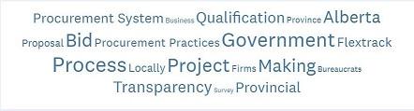
- Acknowledge the support of Administrators and Contractors for the Disaster Recovery objective. When disaster strikes, local businesses usually take the brunt of the impact. Disaster plans and recovery efforts should engage local businesses in helping the community recover.

- Give Alberta’s small business a fair chance – commit to innovation. Government’s use of social and - to a lesser extent, economic incentives are generally resented by contractors. Such incentives are viewed to be in conflict with the pursuit of best value. If incentives are, however, to be employed then small business should expect that incentives be included to redress their issues.
- It is hard to tell how effective government procurement practices actually are. There are a significant number of large multi-national companies that seem to get the greatest benefit, and get high returns on their services. There does not appear to be any simple means for Alberta innovators to easily serve Alberta public sector procurement activities.
- Small companies often cannot compete because of the requirements stipulated by government which are not translatable. The end result is eliminating small companies from the ability to bid. Have governments be aware of the discriminatory practice and alter requirements.
- More support of local suppliers.
- Get rid of large outsourced contracts to companies like … edited out
- We need more small contractor access to government bids! investment in new ideas!
- In order for the Alberta economy to diversify itself from Energy/ O&G we have to start walking the walk around supporting local entrepreneurship. Critical to this is buying locally. We have to value it and make it a priority.
- Policy updates that allow for and prioritize a "try first + buy first" culture are needed. Enough rhetoric.

3. Value for Money requires a commitment to Innovation.
Throughout the survey reference is made to the merit of innovation in advancing the economy and adding value. Innovation is central to government's objective of providing Vision and Leadership. Yet, Contractors view Innovation as compromised in the practice and objectives of public procurement.
Comments frequently reference "waste" as the basis for the very low support for this objective. While several recommendations can be cited to redress the shortfall, most evident is the merit of innovation.
- In many cases, the request for proposals should define the problem and let industry bid with solutions (i.e innovation).
- Once a technology direction is set within a ministry they should not be forced to open the competitive process to every alternative provider in the market.
- Alberta Innovates (i.e. the tax payer) invests 200+M each year into R&D and commercialization yet the (health) procurement system is so risk adverse these investments become questionable as companies are forced to find first customers in other provinces or countries.
- I think the government should do three things:
  - 1) make a list of innovative procurement from Alberta companies
  - 2)dedicate 5-10% of procurement to innovative Alberta companies
  - 3)create plug and play centres to demonstrate innovative Alberta technology Value for procurement dollars rather than adherence to a process
- More openness to new products and processes proven globally versed Alberta only.
- The three bid process precludes Alberta entrepreneurs from submitting new technologies that are unique as they have no comparable bidders. This not the way to grow innovation in Alberta.
- Push for more RFI prior to making a decision on products or solutions. This will help open the opportunities to see ideas and options that may not be known by the department staff making these decisions.
- The AB Government should direct AB Infrastructure to sole source products from AB innovators when those innovators can provide a superior product on a timely basis at a lower price. (e.g. DIRTT).
- When an innovator brings an unsolicited project proposal to the government that would help address priority areas for the government, it should be seen as intellectual theft if the government responds by releasing an RFP to deliver the project that the innovator brought to it. Such intellectual theft causes innovators like us to avoid dealing with the AB Government at all.

4. Ensuring Transparency requires unbiased oversight. A periodic external review is needed for addressing the distrust and suspected favouritism, bias, and waste acknowledged by Contractors and Administrators.
- While rules are on the books to regulate purchasing practices, they are either not being enforced or there is no oversight being provided by a higher level of government, nor is there a complaints process in place.
- I would recommend an audit or review of the procurement processes. Specifically the use of Flextrack, the procurement process used to engage this service, the benchmarks used to determine value and achievement of results, the cost benefit analysis, compliance with GST regulations, conflict of interest, etc.
- A willingness to have politica and senior government officials with industry around the table for open debate on how to be better.
- Regarding municipal IT procurement - get rid of having only 4 pre-qualified vendors and allow all vendors to compete.
- Regarding provincial IT procurement - get rid of … edited out, its a bad idea and is killing IT in Edmonton.
- Some municipalities use the process for finding the cost of a project for budgeting purposes, then disqualify all bidders and repost the work later in the year or in the following year.
- The Procurement Spectrum should be re designed with a Oversight component that includes a cross section of public, private, government, and elected members.
- Provincial GoA’s procurement practices, especially IT Services are corrupt-filled with biases-definitely not competitive--there are many unfair and biased cases that were brought to the GoA procurement management’s attention - which were quickly and secretly dismissed-without any clear and transparent explanations. A very biased and non-transparent set of practices -An ongoing issue and concerns that has never been addressed nor resolved because of clever cover-up.
- Developing proposals in many cases is a waste of time because the bureaucrats have defined the requirements to favour the preferred supplier.

5. Minor changes to public procurement practices should be considered to improve overall efficiency. Several practices core to obtaining Value for Money are identified as in need of review and removing inefficiencies contributing to waste and distrust. Heavy weighting on price is frequently mentioned and Flextrack is identified as an experiment gone wrong.
- More open to information
  - We find that typically at the time of close there is demand for information that could be supplied after the close, which would help with getting more competitive numbers.
  - More modern processes such as e-submissions, opportunities to clarify requirements up to release and even during bid processes needs to be provided.
- Clarity of Work
  - Clear work scope should be included in the walk-thru.
  - Provide procurement documents that are simple to understand (without legal jargon) and improve the fairness of evaluations.
  - Many of the requirements posted though the procurement process are complicated and require access to the people who are responsible for the delivery.
- Certification
  - All evaluations should be done without any vendor information, and all projects/procurement over $5000 should require a qualification process. Still today we say hundreds of projects and agreements made or extended without due process.
  - Procurement is very heavy on asking for certifications and making them conditional for winning contracts. Contracts should be reviewed on merit by qualified personnel and certifications should not be used as a crutch in making decisions. Some RFPs and contract(er) requests are so heavy on certifications plus in such a large number for one contract, that it makes it hard for smaller organizations to compete on merit with large companies.
- Qualifications
  - Procurement should be qualification rather that cost based. Low cost providers are not always best.
  - Move to Qualifications Based Selection models that remove price out of the equation and then do the work under collaborative delivery models such as progressive design build, integrated project delivery, or modified design build.
  - Make budget public for each procurement. Stop making price a criteria.
  - The qualification process should be more transparent.
  - Bring back standing offers with a large pre-qualification process, and then streamline individual contracts to these contractors.
  - The current procurement process in the IT industry has moved to excessive mandatories and the requirement to write an exam to quality. What does not make sense is that there is a preferred vendors list under FasTrak process. This list has become a mailing list and does not ensure that government is identifying qualified vendors. In the absence of pre-defined vendors, each bid needs to be responded to as if it is a raw submission and does not provide any assurance to the Government Departments that the vendor is a proven supplier.
  - Government must have an up-to-date list of suppliers with details of their qualifications and must have a mandatory requirement for all providers to register with the Government.
  - Applicants should be required to have a full time current management personnel presence in the province to apply.
  - Flextrack is a major disincentive and should have it’s payment terminated
- Simplify processes and educate administrators
  - Simplify processes and reduce redundancy
  - Better education for RFP creators.
  - Budget maximum thresholds are too rigid, as a result public projects are delayed.
  - Make the procurement process easier to encourage more public tenders for consulting related services or IT related services. Orgs just use other routes to avoid RFPs or keep using prequalified lists and favouritism to the big four consultant firms.
- Economic Development
  - Stop taxing people to pay for an innovation and procurement system that doesn't work.
  - Lower taxes, let the companies keep the money and provide tax incentives for buying equipment and a further incentive for buying Canadian made equipment.
  - Foster the manufacturing system and let people keep the money so they spend it and support consumer spending.
  - Stop taxing everyone to death as it's just a slow painful decline to the end.
- Social Development – mixed responses
  - There should be a preference to providers managed and owned by women and visible minorities.
  - Hire based on the best person/company for the job - period.
  - STOP THE INSANITY OF HIRING BASED ON PERCENTAGES OF MINORITY, RELIGION OR COLOUR. It has infiltrated our infrastructure, our government, and now our very way of life. Political correctness must end - or western civilization will be destroyed.
  - A model similar to the approach used in B.C. of project labour agreements will have more women and indigenous people involved in the construction of public infrastructure.
- Transparency – waste and bias
  - There needs to be a sealed bid tendering process.
  - The sub-contractors should be submitting separate bids from the general contractor.
  - There should no longer be a reverse auction system used.
  - More transparency
  - Suggest recording any meetings with staff if there is a transparency concern.
  - More transparency.
  - Many of the Provincial projects feel like someone has the inside track, so they should stop wasting our time and just say so, like the Feds do with ACAN.
  - Government should take back the responsibility of running and managing IT projects, bias toward multi-nationals is killing Edmonton’s independent contractor IT industry.
  - Recent bid had the bidders meeting (which was good) halfway through a three week response window. The response was very complex and yet they would not extend even one week. When they RFP with minimal response time, I'm likely not alone in assuming the project is wired and they are just going through the motions. How is this fair. They waste far too much time on the RFP and leave no time for the bid.

6. Modernize Alberta’s Public Procurement. Is public procurement broken? That $Bs are being wasted particularly in construction and infotech is acknowledged - and public. The level of non-support for public procurement throughout the survey and frustration among contractors is palatable. Several recommendations hint at the value of learning from others and collaborating for modernizing public procurement in Alberta.
- Program similar to Federal BCIP program for Alberta produced products
- The current design-bid-build procurement system is outdated and not reflective of responsible use of public funds.
- Get away from conventional Design - Bid - Build delivery models which do not encourage collaboration.
- Modern systems such as IPD better maximize projects outcomes leading to better overall project execution.
- Current entrenched delivery models are a race to the bottom and provide NO VALUE for $.
- Encourage relationship building and trust between those that procure, those that design, and those that build.
- I suggest having a Procurement Committee that equally includes government official and members of the public with experience in the various aspects of procurement (NOT just people from large companies). The members would work on each request and provide advice, oversight of govt practices-->act as Oversight body. (Administrator)
7. Nothing to add – though frustration is apparent. The following comments were received in the request for recommendations, but are not constructive:
- No point at this time! It would be futile...
- Nothing further.
- NO.
- No
- no
- I think if this province wants to diversify it needs to do more than talk which is all politicians appear to do .. that and try to stay in power.
- Municipal procurement is worse than its provincial counterparts.
- Not at this time
- Public procurement in the areas I've worked with are constricted and ineffective.
- Small firms take greater risk than large firms if preparation effort is unfunded/unsalaried
- Get government and bureaucrats out of the business
- Visit the minster, join the party
- I have a ton that we could go through.

- Survey discredited. We can do better
During the survey we were criticized for the broad distribution of the survey and the survey’s leadin title “Is Alberta’s Public Procurement Broken?
- Re-writing the survey. (Administrator)
- Leading (the survey questionnaire) with public procurement is a source of waste, fraud and corruption discredits and biases this survey. It is NOT a factor of large financial flows. Procurement problems are created by business lines and procurement rules having competing interests internal to government. (Administrator)
Conclusion. The survey was designed to obtain an independent view of public procurement in Alberta. It was triggered by reports of waste and repeated complaints about public procurement bias received by ABCtech. The objective has been met and the results too obvious and significant to ignore. What is not so obvious is how to re-establish trust among the various stakeholders in the system. Of the array of recommendations cited above, these would appear to be the more reasonable for starters:
- Establish Oversight. Establish standard expectations and expect all bidders to complete a simple anonymous evaluation of the procurement process accompanying each bid..
- Continuous Improvement. Engage a 3rd party to conduct an audit of the public procurement system – it’s practices and objectives engaging contractors and administrators. Target the gaps and follow-up on improvements annually. Propose recommendations and standards.
- Engage Industry. Review all public procurement practices with the intent of increasing small business engagement, promoting innovation, and incenting collaboration/partnering.
- Special Consideration for Emerging Technologies. Emerging technologies are challenging all public procurement practitioners to remain up-to-date on the latest innovations. This is particularly true in information management affecting all industries and all departments - healthcare in particular – given the extraordinary costs and waste reported in the development of health information systems. The rate of change is so great as to make the task of encouraging innovation while also containing costs, managing risk and avoiding waste.
- Listen. The Government of Alberta should establish an Industry Advisory reporting to the Minister of Service Alberta with responsibility to file an annual report with the Minister and the public on the status of public procurement.
- Learn. Host an annual conference for stakeholders to be exposed to best practices in public procurement
Public procurement spends $Billions annually and is fundamental to public services throughout the province. It is viewed with distrust and needs fixing. There will be those who rely on the status quo, who will resist reform. However, with the shared objectives of Value for Money and Transparency and Effectiveness including a high regard for Alberta enterprise and innovation, the proposed recommendations should be widely accepted.

