
CanTech Credit Union - Executive Overview

Launching an ABCtech Credit Union (CanTech Credit Union)

We are proposing that ABCtech form a credit union from its membership/affiliate networks. For the purposes of this document we'll call it CanTech Credit Union. CanTech’s mission will be to provide innovative financial products that align with and meet the needs of Alberta based technology startups. Although CanTech would initially be an Alberta credit union, it could, eventually, be replicated in other provinces.

CanTech will develop a suite of financial services including - but not limited to, conventional Level A debt financing services as well as a host of closely associated (1) mutual funds, (2) hedge funds (3) Peer to Peer investment platforms and higher risk Level B debt facilities. CanTech will, in the first instance, be providing commercial and industrial financing services but could, if members' approve, provide regular banking: checking, savings, term deposits, GIC, bonds, foreign currency exchange and personal lending services.

CanTech Mission: CanTech Credit Union will serve the community by becoming a leading force in diversifying the economy by financing the commercialization of Alberta technology.

CanTech Vision Statement: We seek member funds to empower entrepreneurs allowing them to develop and commercialize new and innovative technology by providing intangible asset identification/security, finance and other necessary resources.

CanTech's Community Development Commitment

CanTech's mission and vision are drawn from ABCtech's commitment to the development of a healthy and growing technology industry in Alberta. We distinguish our organization by helping companies become organizationally and financially sustainable rather than simply maximizing shareholder value. We commit to the companies we serve and the community we live in by creating an integrated financial pathway to help talented entrepreneurial Albertans realize their ambitions here in the Province.

1. Encourage Technology Development in Alberta

Regrettably, a technology success in Alberta most often involves the sale of a world-class technology to a foreign corporation or venture capital firm. This represents a direct loss of opportunity for Alberta-based innovators and a missed opportunity for economic diversification.

There is a significant opportunity for a well positioned and properly structured credit union to both serve the interests of technology entrepreneurs in Alberta and fill a gap in Alberta's finance sector.

CanTech's primary aim is support technology throughout all stages of its growth to build successful technology firms that remain headquartered in Alberta, serving the community and providing valuable networking opportunity for other ventures to follow.

2. Restructuring Alberta's Credit Markets

Like all sectors in our economy, technology needs its own nutrient-rich commercial biosphere. This protective ecosystem wants, first of all, the raw material of innovation but it also needs access to vital nutrients including expertise in commercialization, production, distribution, global marketing, sales and finance in order to create the conditions for life.
Clearly, we have many of the ingredients for this biosphere already. Alberta is rich in innovation and has expertise of all sorts, including business development specialists, technology incubators and related support services. What it lacks is access to level -two finance.
Regrettably, capital markets are out of sync with the Alberta’s new economic reality. A bias has developed that is directing the savings of Albertans toward out of the province passive investment.
CanTech and its venture finance partners could redirect some part of this capital toward active investment-ready opportunities that help grow and diversify the Alberta economy.

3. Provide a Better Return on Alberta's R&D investment

Gross domestic expenditures on public and private research and development (GERD) in Alberta were $3.6 billion in 2013 and will top $4.0 billion in the near future. The technology results are impressive. In areas of excellence like bio refining, (space age) materials, nanotechnology, clean tech, biotechnology and health care, world-class innovation is being generated in Alberta based institutions.

At present there is very little return on this investment, CanTech will work to increase the community returns by filling the gaps in our technology biosphere.

4. Provide Opportunities for Albertans to invest in Alberta

Several billion dollars a month in managed investments (RRSPs, TSFAs, pension and mutual funds) leaves Alberta to be invested on Bay Street or Wall Street. CanTech will help mobilize some part of Albertan's savings by providing individuals with opportunities to participate at all levels. Investors will be encouraged to make small investment in the higher risk technology funds; doing will give these investors a right to investment larger sums once critical commercial/risk thresholds have been reached.

Sony’s lessons for Alberta

Sony Corporation of Japan was one of the 20th century's most successful companies. Sony had a 'rags to riches' backstory, rising from complete obscurity to become of a world leader in consumer electronics. Its success proves that Alberta can develop a thriving technology sector.

There is a feeling amongst many that the natural role for Alberta in the global economy is to provide energy products and that it’s too out-of-the-way to be a hub for advanced technology. Well, in the early 1950s, no country was more out of the way for technology success than Japan.

After the Second World War, Japan lay in ruins. The war had destroyed its economy and the country was under occupation. Coal mining, textiles and agriculture were the primary industries. Consider that Japanese exports were minuscule in those dark days - composed of cheap disposables - like those colourful paper umbrellas that adorn cocktail glasses.

At the time, Sony was a small start-up company selling a few hundred tape recorders a year in post-war Japan. The company had no track record, no exports and few prospects. Sony’s founders, Morita Akio and Masura Ibuka, had read about Bell Lab's invention of the transistor and recognized immediately that it would revolutionize radios. The transistor radio, as it soon came to be known, was born. It was an immediate smash hit for Sony and a breakthrough that launched the company on its road to global supremacy in 20th century consumer electronics.

Modern economists believe, and encourage governments to believe, that investment in R&D, particularly at the university level, is the best (if not the only) means of developing a high-tech sector in the economy.

Sony’s success proves this idea is only partially true. Success in Sony's case depended upon commercial genius and market savvy. These qualities were less innate than hard-earned. Sony's so-called genius was built on experience, a lot of hard work and an intimate knowledge of how corporations and markets work in the real world. This general knowledge was augmented by industry specific knowledge about their customers, marketing and distribution, and a refuse-to-lose management determination.

Finally, Sony had generous access to risk capital its competitors’ lacked. The company took advantage of a unique set of circumstances in 1950s Japan. After the Second World War, the government of Japan recognized it would have to make special efforts to rebuild the war-ravaged economy. It targeted various industry groups as likely candidates for growth and capitalized specialized banks, mandating them with the sole purpose of financing and modernizing local Japanese companies.

The Japanese government’s initiative proved to be the catalyst. Through its development ministry (MITI), the government stimulated the movement of capital and labour out of declining industries, such as coal and textiles, and into modern industries like electronics, steel, petrochemicals and automobiles. This unique combination of urgent societal need, political will and targeted financial institutions created an integrated support system for Japanese companies during that turbulent period of their history.

The problem that CanTech will help overcome

According to University of Ottawa economist (and former Parliamentary Budget Officer for Canada) Kevin Page, a major impediment to growth in Canada (and now Alberta) is the lack of investment. Investment in Canadian industry, other than resources and property, flat-lined years ago at very low levels, leaving many sectors of our economy undercapitalized. With commodity prices at historic lows, Alberta in needs to change gears.
With the collapse of oil prices, conventional wisdom suggests that Alberta needs to do more - make more concessions - to create an attractive investment climate for institutional investors. But we believe the secret to diversifying Alberta’s economy through technology starts at home, with Albertans investing locally in their own future.
A significant proportion of Alberta's innovation finds its way into small to medium sized enterprises (SMEs) that attempt to commercialize these technologies and take them to market.
The problem is, there is the investment for technology is very poorly developed in Alberta. As a result very few of the thousands of technology rich startups that exist today are able to escape the Starvation Zone and become successful commercial businesses in Alberta.
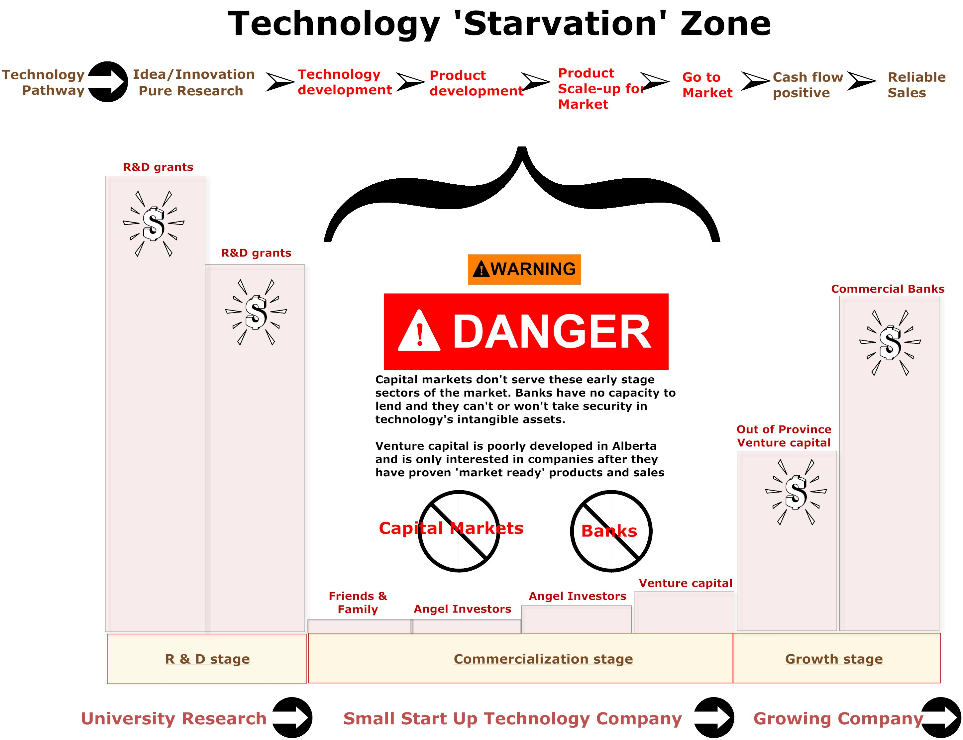
What is the Starvation Zone?

The Starvation Zone is the financial black hole that technology meets when it emerges from the laboratory. Banks, for example, are NOT equipped to finance (pre-revenue) start-up ventures and don't (or won't) recognize the collateral value of intangible assets. As a result, low-cost bank financing channels are closed to these companies, limiting their growth potential.
The vast majority of SME’s must rely on angel investors or family and friends to finance the earliest stages of their business. But this channel of finance is limited and as a result most SME’s eventually approach venture capitalists.
Venture capital or VC is expensive and very scarce in Alberta; regrettably, VC business models can address only a small fraction of the market and are specifically designed for rapid ROI (return on investment). VCs finance only those companies with very high return potential. Despite choosing only a handful of winners, the VC success ratio is very low; only one success in about ten ventures. VCs are further limited in the capital sums they can invest. It’s very seldom enough to realize the full global potential of the venture.
Regrettably Canada’s innovation is stymied because our innovators are unable to gain access to financial capital and the other human and institutional resources they need to realize their full potential. We have identified a number of points of differentiation that we believe will (1) improve the success ratio for technology ventures and (2) create more technology winners in Alberta

CanTech and its partners will support technology through the Starvation Zone

- Investment ready services: CanTech will partner with Pro-Ventures Pathway Inc, a global team of experts, commercialization specialists, with contact into marketing and distribution channels in the US and China, accelerating speed to market.
- The PVP team utilizes an intangible asset licensing strategy that has the advantage of keeping the core technology safe from commercialization failure, while reducing the conflicts between R&D team and the commercialization team.
- Integrated technology pathway: CanTech will partner with closely associated venture funds whose role will be to make early stage equity investments in appropriately vetted (investment ready) technology ventures. By syndicating the investment over many (RRSP and TSFA qualified) investors we'll provide the higher risk resources necessary to complete product development and scale up stages while reducing individual investors' risk.
- Full suite of resources: CanTech Credit Union will be able to provide a full suite of equity/debt financial services and other necessary resources from the company’s product scale up stage through to a cash flow positive commercial success.
- Asset security: We’ll identify and capitalize the underlying intangible assets in the technology venture and capitalize them on the balance sheets. These non-traditional assets will then be used (where appropriate) as security for equity and Level B debt financing. This will reduce the due diligence requirements, (speed to finance) lower the costs of capital and provide the resources for a longer-term strategy.

Why a Credit Union?

A technology-focused credit union could help address gaps and inconsistencies in Alberta's capital market structure.
While there are resources (grants, facilities, related expertise) available for conducting the primary R&D through university and related funding channels, once a technology is out in the market the support and financing options diminish significantly.
Banks, for example, are not equipped to finance (pre-revenue) start-up ventures and don't (or won't) recognize the collateral value of intangible assets. As a result, low-cost bank financing channels are closed to most technology start-ups.
Alternative financing does exist in private 'angel' investor networks or venture capital (VC). Regrettably both angel and VC finance are expensive and very scarce in Canada. As a result there is a large and unrealized opportunity for a properly structured financial institution serving this under-performing sector of the Canadian economy.
Credit Unions are like traditional banks in that they offer financial products and services to their customers. A key advantage of credit unions is they are member driven and member focused, and as such can custom design their suite of financial services to the particular needs of its members.
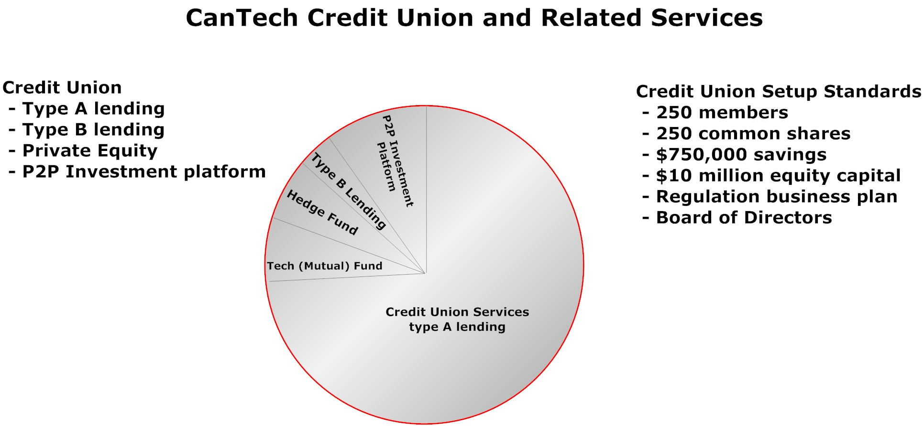

Credit Union as part of a Technology Finance Eco-system
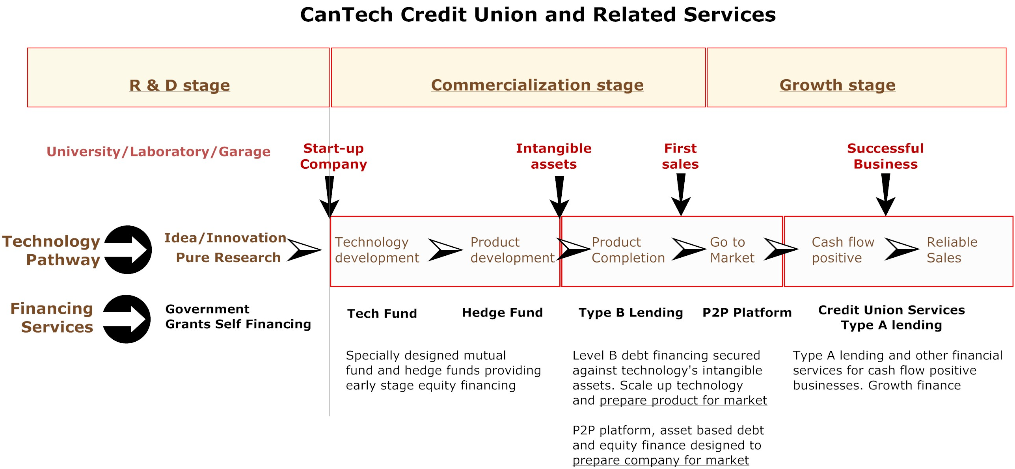

Oxygenating the Technology Biosphere

Establishing a technology credit union in association with early stage (higher risk) funds and P2P investment platform is a critical component in establishing an integrated pathway for technology in Alberta. These locally targeted funds have certain advantages for technology developers, but also for investors.

The early stage venture funds would adopt a shotgun approach to financing pre-commercialization ventures. By raising relatively small amounts (a few thousand dollars) from many thousands of individuals’ TSFA and RRSP accounts, and (possibly) providing a insurance for that investment, an individual investor’s personal risk is manageable.

The fund will take on the early – higher – risk assignment of maturing Alberta technology through the technology development and product development states, getting these organizations to the point where they’re investment-ready with a reasonable chance of commercial success.

One the company has finalized its technology and identified its key market segments the intangible assets underlying the technology begin to approach collateral grade, for banking purposes. The CanTech Credit Union will play a significant role in the commercialization process by advancing Level B debt financing secured by these maturing assets. As the assets reach full collateral grade, the higher cost Level B financing will be replaced by more conventional Level A debt instruments.

Formal treatment of the (presently invisible) intangible assets on technology balance sheets would provide management with multiple options for their growth strategy and strengthen many company’s financial metrics; perhaps help quantify leverage-able collateral.

The P2P members-only platform will be reserved for individuals or institutions that invest in the early stage funds. They’ll be given priority access to the growth stage financing opportunities, when the companies have proven their commercial viability and need lower risk growth capital.

Several kinds of reforms are needed to deliver a more diversified economy in Alberta, which CanTech and its partners will help deliver. Taken together, these reforms will create an integrated pathway for technology, an oxygenated biosphere for Alberta innovation from lab to market.

This pathway will accelerate Alberta innovation through the Starvation Zone and deliver extraordinary results, setting the stage for growth in other under-capitalized sectors in the local economy, like health care, rural development, First Nations’ business opportunities and others. Done successfully, this pathway will help build a new and much more diversified future for Albertans.

Why ABCtech?

ABCtech is ideally suited to be the sponsoring organization for this new Credit Union. ABCtech has evolved to a point where it has over 13,000 subscribers and 250 members interested in technology and commercialization of technology. Credit Unions need members and ABCtech has sufficient members to support the initiative. More importantly, ABCtech's members have a common goal of increasing the success rate of technology businesses in Canada. We recommend the following:

- CanTech members are drawn from ABCtech membership.
- We also recommend $1 per share; to become a credit union member the minimum common share is ONE share.
- Multiple share purchases be promoted as there is no upper limit for purchasing common shares.

There will be two types of memberships: business membership and individual membership. Business membership includes all Alberta corporations, non-for-profit organizations, unions, self-employed businesses, professional associations, municipalities, political organizations/campaigns, etc. Individual membership means anyone who has been resided in the province (Alberta).

What are the Minimum Requirements?

Minimum Start-up Requirements: 250 members, $250,000 common shares, and $750,000 savings (total capital minimum to be licensed is $1 million; but recommended $10 million if we want to provide checking and clearing services to our members). The corporation will meet the capital account and capital base requirements referred to in Section 35(b) of the Act, of at least $5,000,000 in the case of a deposit taking trust corporation and $3,000,000 in the case of a loan corporation, $2,000,000 in the case of a special purpose trust corporation or other amount as required by the Minister.

What's a Bond of Association?

Credit unions are a provincial responsibility, and the government makes it relatively straightforward for an existing association which special needs to set up a credit union to meet those needs. Doing so makes financial as well as organizational sense. While the normal fees for establishing a Credit Union are $1 million, an existing organization can establish a Credit Union by posting a Bond of Association for $10 thousand.

Expectations

CanTech Credit Union is being proposed as a solution for its members and stakeholders by:

- Recognizing and bringing value to those intangible assets associated with technology commercialization early on in the process;
- Monetizing the value of early stage technology development that delivers realizable financial benefits to members of a credit union but also with outside investors; and,
- Developing a dynamic relationship with individuals and organizations, which would then feed into the specific development programs offered by the credit union.

ABCtech, as a catalyst for establishing CanTech Credit Union, would be able to support its interest in the commercialization of technology in Alberta by creating centres of knowledge through its affiliation with research organizations, by attracting new members to ABCtech who bring specialized expertise, and liaising with public policy makers.

Outcomes

The primary outcome would be a “Made in Alberta” solution for a financial institution designed specifically for commercializing technology. Secondary outcomes would include:

- Increased funding for technology commercialization;
- Higher rate of successful commercialization;
- More robust economic diversification;
- Higher rates of return for credit union members and investors;
- Momentum to foster a wholesale change in the culture of financial institutions seeking to better serve the needs of their customers.

